Mexico:
Natural Disaster Fund FONDEN: A Review

January 2012

Disaster Risk Financing and Insurance Program, GFDRR and FCMNB
Latin America and Caribbean Region
Global Facility for Disaster Reduction and Recovery

THE WORLD BANK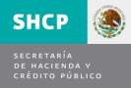

Table of Contents

Table of Contents 1
Acronyms and Abbreviations 3
Acknowledgements 4
Executive Summary 5
Chapter 1: Introduction 7
Chapter 2: Mexico Disaster Risk Profile 8
Natural Hazards 8
Vulnerability to Natural Hazards 14
Brief History of Civil Protection and Disaster Management in Mexico 17
Chapter 3: The Natural Disaster Fund FONDEN 21
FONDEN’s Mandate and Scope of Activities 21
FONDEN’s Financial Accounts 22
FONDEN Program for Reconstruction 25
The FONDEN Trust 26
FONDEN’s Revolving Fund 28
FONDEN Operating Guidelines 29
Phase 1: Request for Declaration of Natural Disasters 32
Phase 2: Damage Assessment and Requests for FONDEN Resources 35
Phase 3: Disbursement of Resources and Implementation of Reconstruction Activities 39
Phase 4: Dissemination of the Report on Post-Disaster Activities 43
FONDEN’s Innovative Use of Information and Technology 43
Chapter 4: FONDEN Financial Management 49
Disaster Risk Profile of Federal and State Governments 49
Disaster Risk Profile of FONDEN 50
Disaster Risk Financing Strategy of FONDEN 52
Annual Budget Allocation 54
Risk Transfer Instruments – Indemnity-based reinsurance 55
Risk Transfer Instruments – Catastrophe bond 55
Enhancing Disaster Risk Financing and the Insurance Strategy 58
Chapter 5: Towards Integrated Risk Management 61
Mexico’s Approach to Comprehensive Risk Management 61
Lessons Learned 62
Conclusion 62
References 64
Additional Resource Material 65
Glossary 66
Annexes 70
ANNEX 1: Description of Phenomena Identified in Mexico’s General Law of Civil Protection 71
ANNEX 2: Selected Earthquakes in Mexico of General Historic Interest 72
ANNEX 3: Mexican State and Federal District Populations 73
ANNEX 4: Members of the FONDEN Trust Technical Committees 74
ANNEX 5: Disaster Declarations by Mexican States in 2009 75
ANNEX 6: FONDEN’s Previous Fund Allocation Process until 2010 76
ANNEX 7: Overview of FONDEN’s New Procedures from 2011 77
ANNEX 8: Illustrative Examples of Disaster Events and Access to FONDEN Resources in 2010 80
ANNEX 9: Examples of Authorized Resources for Disaster Declarations in 2011 83
ANNEX 10: Examples of Funds Approved for Immediate Partial Support in 2011 84

Acronyms and Abbreviations
Banobras | Banco Nacional de Obras y Servicios Públicos (National Bank of Public Works and Services)
CENAPRED | Centro Nacional de Prevención de Desastres (National Centre for Disaster Prevention)
CADENA | Componente de Atencion a Desatres Naturales (Agricultural Fund for Natural Disasters)
CONAGUA | Comision Nacional de Agua (National Water Commission)
DGRMSG | Dirección General de Recursos Materiales y Servicios Generales (Directorate General of Resources, Materials, and General Services)
FIPREDEN | Fideicomiso Preventivo de Desastres Naturales (Natural Disasters Preventive Trust)
FOPREDEN | Fondo para la Prevención de Desastres Naturales (Natural Disasters Prevention Fund)
FONDEN | Fondo de Desastres Naturales (Natural Disasters Fund)
GFDRR | Global Facility for Disaster Reduction and Recovery
GIS | Geographic Information System
PACC | Programa de Atención a Contingencias Climatológicas (Climate Contingencies Program)
R-FONDEN | Riesgo-FONDEN (FONDEN Risk)
SAGARPA | Secretaría de Agricultura, Ganadería, Desarrollo Rural, Pesca y Alimentación (Ministry of Agriculture, Livestock, and Rural Development)
SCT | Secretaría de Comunicaciones y Transportes (Ministry of Communications and Transportation)
SEDESOL | Secretaría de Desarrollo Social (Ministry of Social Development)
SEGOB | Secretaría de Gobernación (Ministry of the Interior)
SEP | Secretaría de Educación Pública (Ministry of Education)
SSA | Secretaría de Salud (Ministry of Health)

Acknowledgements
This report is co-authored by Rubem Hofliger (Director General, Natural Disaster Fund (FONDEN)), Olivier Mahul (FCMNB and Global Facility for Disaster Reduction and Recovery (GFDRR), World Bank), Francis Ghesquiere (Latin America and Caribbean Regional Urban, Water & Disaster Risk Management Unit, World Bank), Salvador Perez (Deputy General Director, Insurance, Pensions, and Social Security), with inputs from Laura Dorling van der Oord (Consultant, World Bank), Charlotte Benson (Consultant, World Bank), and Daniel Clarke (Actuarial Consultant, World Bank).
Special acknowledgements are extended to the Government of Mexico, and especially to José Jaime Pérez González (Director, Analysis and Evaluation for FONDEN) and Juan Miguel Adaya Valle (Coordinator of Risk Analysis Projects, Insurance, Pension, and Social Security Unit, Ministry of Finance) for sharing valuable information and insights on the inner workings of FONDEN and experiences to date.
The team gratefully acknowledges funding support from the Mexico Country Unit of the World Bank, the GFDRR and the Swiss State Secretariat for Economic Affairs (SECO).
This document is a product of the staff of the World Bank. The findings, interpretations, and conclusions expressed in this paper do not necessarily reflect the views of the World Bank or the governments they represent. The World Bank does not guarantee the accuracy of the data included in this work. The boundaries, colors, denominations, and other information shown on any map or figure in this work do not imply any judgment on the part of the World Bank concerning any territory or the endorsement or acceptance of such boundaries.

Executive Summary
Mexico is highly exposed to multiple natural hazards. Its vast national territory experiences a wide variety of natural geological and hydrometeorological phenomena. About 40 percent of Mexico’s territory and a total of 31.3 million people are exposed to storms, hurricanes, and floods. Climate change is expected to contribute to an increase in both the frequency and severity of hydrometeorological hazards in Mexico.
The human and financial losses caused by natural disasters in Mexico are on the rise. Throughout its history, Mexico has endured disaster situations and continues to experience earthquakes, volcanic eruptions, hurricanes, wildfires, floods, landslides, and droughts. Both federal and local governments have faced substantial costs associated with emergency response, rehabilitation and reconstruction.
The Fund for Natural Disasters, FONDEN, was established in 1996 and became operational in 1999. Following two devastating earthquakes in 1985, the Federal Government of Mexico established a National System of Civil Protection. FONDEN was created as a budget line in the budget law in 1996 and became operational in 1999, following Hurricane Pauline, which struck Acapulco in 1997 and severe floods in Chiapas in 1998. FONDEN is a mechanism to finance the post-disaster recovery and reconstruction of public assets. FONDEN’s policies, procedures, and financial instruments provide a useful example of a disaster risk financing and insurance vehicle developed by a government.
Mexico’s FONDEN consists of three primary financial accounts: (i) the FONDEN Program for Reconstruction; (ii) the FONDEN Trust; and (iii) the Revolving Fund. Collectively, these instruments assist the Government of Mexico in its efforts to respond quickly to natural disasters, providing funding for humanitarian aid, rehabilitation and reconstruction. Continuous changes are made to enhance the efficiency and effectiveness of these instruments.
- The FONDEN Program for Reconstruction provides financial support to rehabilitate and reconstruct public assets. It focuses on the reconstruction and restoration of (i) public infrastructure at the three levels of government (federal, state and municipal); (ii) low-incoming housing; and (iii) forestry, protected natural areas, rivers, and lagoons.
- The FONDEN Trust provides resources for approved activities under the FONDEN Program. It also acts as the contracting authority for risk transfer mechanisms, including insurance and catastrophe bonds.
- The Revolving Fund is designed to respond to the immediate needs of affected populations in the event of a natural disaster as FONDEN’s financial instrument for emergency response and the acquisition of humanitarian aid supplies.
The Federal Budget Law requires that no less than 0.4 percent of the annual federal budget should be allocated for FONDEN and related activities through a dedicated budget line item. The Mexican Congress approved a new Federal Budget Law in 2006 which stipulates that no less than 0.4 percent of the total federal budget should be allocated at the beginning of each fiscal year to FONDEN, the preventive fund FOPREDEN, and the Agricultural Fund for Natural Disasters. This amount is net of the uncommitted funds of the FONDEN Trust at the end of the previous fiscal year. In practice, the minimum 0.4 percent requirement – equivalent to around US$800 million in 2011 - has become the standard budget appropriation for these programs. Should this appropriation be insufficient, the law stipulates that additional resources must be transferred from other programs and funds, such as the oil revenue surplus.
The FONDEN resources are leveraged with market-based risk transfer instruments. Despite FONDEN’s annual budget appropriation, variations in funding can occur and there are often funding shortfalls in years of greater disaster intensity or frequency of occurrence. To further manage the volatility of the FONDEN budget and to leverage its resources, FONDEN is allowed to transfer disaster risks through insurance and other risk transfer mechanisms such as catastrophe bonds. It should be noted that FONDEN is not allowed to contract debt.
The Government of Mexico has established a strong link between its technical and financial arms for natural disasters. The National Centre for Disaster Prevention (CENAPRED) acts as the technical arm for disaster risk reduction and works closely with FONDEN, the financial vehicle for disaster management.
Only limited financing is still available for disaster prevention. Minimal resources have been provided through FONDEN’s preventive window, FOPREDEN. Instead, the vast majority of disaster-related budget allocations have been used by FONDEN for post-disaster reconstruction. However, increased attention has been placed on reconstruction activities that ‘build back better’, including via the provision of FONDEN funding for the relocation of public buildings and/or communities to safer zones, and on reducing the exposure of public assets to disaster risks.
The Government of Mexico is moving towards a comprehensive disaster risk management strategy. By balancing investments in ex ante prevention and post-disaster reconstruction, the government intends to significantly increase the protection of the Mexican population and its public infrastructure against natural disasters.

Chapter 1: Introduction

Mexico’s Natural Disaster Fund (El Fondo de Desastres Naturales), commonly referred to as FONDEN, was established by the Government of Mexico to provide fast and effective post-disaster financing for emergency, recovery and reconstruction purposes. FONDEN incorporates policies, procedures, and financial instruments to protect Mexico’s people and assets against disasters. It offers an insightful example of a financial vehicle that governments elsewhere could consider when planning national disaster risk management strategies and related financing mechanisms. Governments elsewhere could benefit from reviewing FONDEN’s experiences to date and its evolution over time to enhance its effectiveness.
This paper is intended to provide an overview of the key features of FONDEN for use by policy makers in other countries. It does not provide an exhaustive description of all aspects of FONDEN and related activities. Instead, in view of its intended audience, effort has been made to highlight areas of particular relevance and applicability to other disaster-prone countries. Interested readers can access the following website for further information on FONDEN: http://www.proteccioncivil.gob.mx/en/ProteccionCivil.
The report consists of five chapters including this introduction. Chapter 2 describes Mexico’s disaster risk profile and identifies the main types of natural hazards and related exposure. A brief history of Mexico’s civil protection system and the evolution of its disaster risk management activities are also presented. Chapter 3 provides an overview of FONDEN and details on each of its financial instruments, its fund allocation process, and its innovative use of technology. Chapter 4 examines FONDEN’s funding requirements to meet its mandated responsibilities and its current disaster risk financing strategy. Insights on the continued development of Mexico’s risk financing strategy and the use of risk modeling are also shared. Chapter 5 focuses on the progressive development of comprehensive risk management in Mexico, identifying lessons learned, current challenges, and best practices. Background information on Mexico and additional details on specific aspects of FONDEN and related topics are provided in a series of annexes.

Chapter 2: Mexico Disaster Risk Profile

Mexico is ranked as one of the world’s most exposed countries to multiple types of natural hazard. As Mexico’s large urban centers continue to attract more inhabitants, the combination of natural hazards and concentrated densities of people in high-risk areas has dramatically increased the vulnerability of its population and assets to disaster events.
This chapter provides an overview of disaster risks and related vulnerability in Mexico. It begins by presenting the context of disaster risk in the country, including a summary of the main types of disasters that have occurred in recent history and related damage. A brief history of Mexico’s civil protection system and an account of the evolution of the country’s disaster risk management activities are also provided.

Natural Hazards
Due to the diversity of its geography, Mexico is exposed to a large variety of geological and hydrometeorological phenomena, including earthquakes, volcanic eruptions, hurricanes, wildfires, floods, landslides, and droughts. Refer to Annex 1 for a description of the natural phenomena identified in Mexico’s General Law of Civil Protection. See Figure 2.1 for images of the main types of natural hazards in Mexico.
Figure 2.1. Main Natural Hazards in Mexico
- Seismic Risks
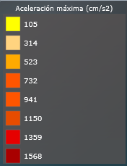
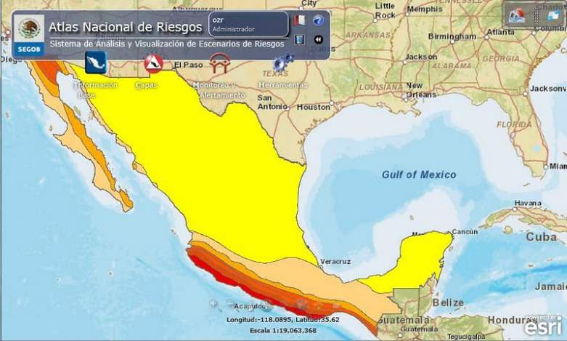
Source: CENAPRED (2011).
- Active Volcanoes
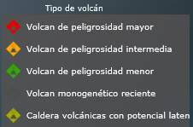
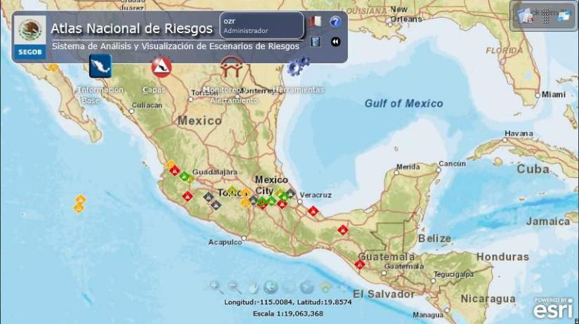
Source: CENAPRED (2011).
- Tsunami-prone Areas

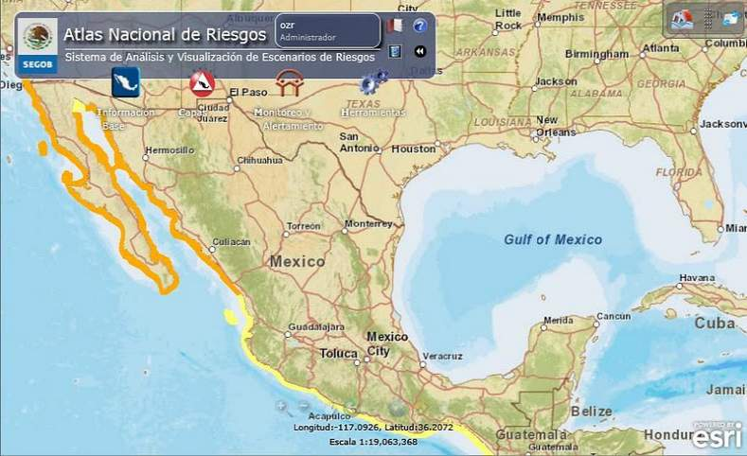
Source: CENAPRED (2011).
- Tropical cyclones
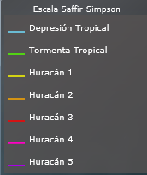
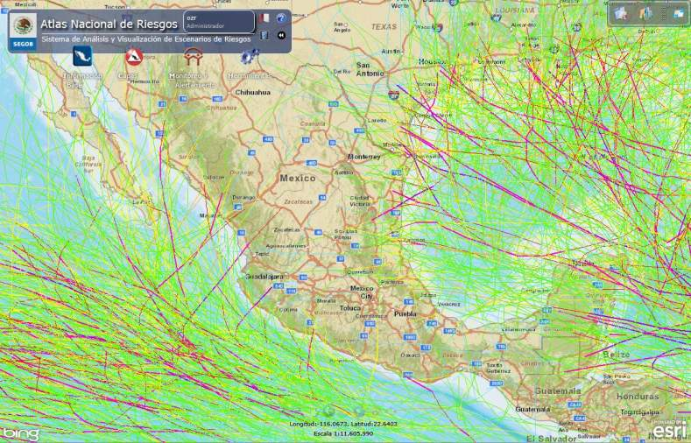
Source: CENAPRED (2011).
- Flood-prone Areas
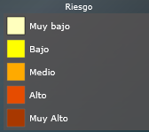
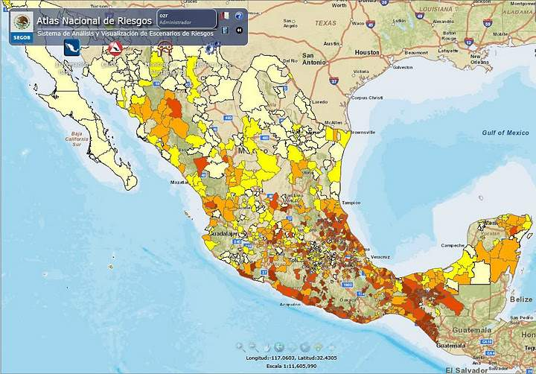
Source: CENAPRED (2011).

Mapa de peligros por sequía en México
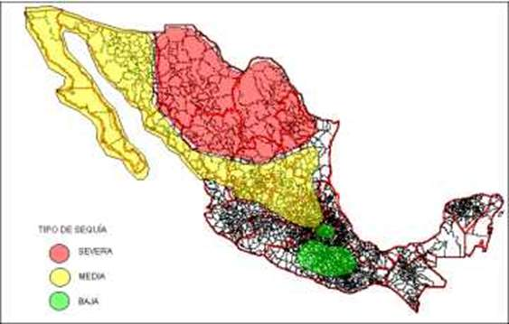
Source: CENAPRED (2011).

Mexico experiences more than 90 earthquakes with a magnitude of 4.0 or above on the Richter scale on average annually (FONDEN 2011). As such, the country’s seismic activity is ranked as one of the highest in the world. This seismicity is mainly due to the activity of several tectonic plates upon which the country is situated, in addition to a series of continental and regional faults that cross and surround the country. The tectonic plates include the Cocos Plate, off the Pacific and the San Andreas Fault, and the Clarion Plate, running north to south and east to west. The Mexican states with the highest incidence of earthquakes are located in a belt stretching from Chiapas to Jalisco and taking in the states of Oaxaca, Veracruz, Guerrero, Michoacán, Colima, Mexico, Morelos, Puebla and the Federal District. There is also a strip of seismic activity along the country’s Pacific coastline, extending through the states of Nayarit, Sinaloa, part of Sonora, Chihuahua and Baja California. The capitol, Mexico City, is highly exposed to earthquakes due to the ancient lake bed sediments that lie underneath the city. Refer to Annex 2 for a list of earthquake events in Mexico.
A Trans-Mexican Volcanic Belt extends from east to west across central-southern Mexico and contains nine volcanoes that have erupted in the past. The metropolitan area of Mexico City is located within this belt. The city is exposed to potential eruptions of Popocatépetl, Nevado de Toluca and Jocotitlán, and to monogenetic scoria cones in the Sierra Chichinautzin Volcanic Field.

Tsunamis

Un tsunami o maremoto en español, es una secuencia de olas que se generan cuando cerca o en fondo del océano ocurre un terremoto; a las costas pueden arribar con gran altura y provocar efectos destructivos: pérdida de vidas y daños materiales. La gran mayoría de los tsunamis se originan por sismos que ocurren en el contorno costero del océano pacifico mexicano, de las zonas de hundimientos de los bordes de las placas tectónicas que constituyen la corteza del fondo marino. Otras causas mucho menos frecuentes de tsunamis son las erupciones de volcanes submarinos, impacto de meteoritos o deslizamientos de tierra bajo el mar. Los tsunamis se clasifican en locales, cuando el sitio de arribo se encuentra dentro o muy cercano a la zona de generación, regionales, cuando el litoral invadido está a no más de 1000 Km y lejanos, cuando se originan a más de 1000 Km.

Hurricanes, heavy rains and floods occur with high frequency. The most vulnerable areas are the Yucatan Peninsula and coastal regions in the Gulf of Mexico and along the Pacific Ocean. Mexico experiences tropical cyclones during the summer months and polar fronts associated with heavy rainfall throughout its territory in the winter. In addition, heavy, albeit short, storms occur. See Figure 2.2 for satellite images of hurricanes approaching Mexico.

Los incendios forestales tienen una ocurrencia y propagación no controlada, afectando a selvas, bosques o vegetación de zonas áridas o semiárida. Los meses durante los cuales ocurre la mayor cantidad de incendios son de enero a mayo, lo cual coincide con la temporada de heladas y sequía, cuando la cantidad de material combustible es relativamente elevada. Existen diversos factores que tienen incidencia en el inicio del fuego, su desarrollo y las medidas para atacarlos, entre estos se encuentran, el clima, el material combustible, la topografía del terreno y las actividades humanas; los incendios atribuibles a estas últimas causas representan el 97% del total de los incendios que se producen en el país. Para que un incendio permanezca y se propague es necesario que exista un cuarto elemento, la reacción en cadena, la cual se produce entre el combustible y el oxígeno con la ayuda del calor.

En México desde hace décadas se ha venido desarrollando una estrategia general de prevención y control de incendios forestales, sistematizada a través del Programa Nacional de Protección contra Incendios Forestales, y en cuya aplicación participan instituciones de los tres órdenes de gobierno, organismos civiles y voluntarios.

Sequía
La sequía es un fenómeno meteorológico que ocurre cuando la precipitación en un período de tiempo es menor que el promedio, y cuando esta deficiencia de agua es lo suficientemente grande y prolongada como para dañar las actividades humanas. La magnitud, duración y severidad de una sequía se pueden considerar como relativos, ya que sus efectos están directamente relacionados con las actividades humanas, es decir, si no hay requerimientos por satisfacer, aun habiendo carencia total del agua, la sequía y su presencia son discutibles desde un punto de vista de sus efectos. El reconocimiento de la sequía como fenómeno hidrológico extremo, dista mucho de tener las características de otros eventos como las grandes avenidas; por ejemplo; se ha llegado a mencionar que la sequía es un "no evento” debido a que su ocurrencia, sobre todo en su inicio, no es fácilmente detectable como tal, sino que se le reconoce por los efectos que provoca.
Las principales causas de las sequías están relacionadas con cambios de las presiones atmosféricas y alteraciones en la circulación general de la atmósfera, generados por modificaciones en el albedo superficial, la existencia de una espesa capa de polvo en la atmósfera, cambios en la temperatura de la superficie de los océanos y mares e incrementos en las concentraciones de bióxido de carbono, ocasionan variaciones espacio-temporales de las precipitaciones.
Así, México tiene gran parte de su territorio en la franja de alta presión de latitud Norte, por lo que estas zonas son áridas y semiáridas, coincidiendo en latitud con las zonas de los grandes desiertos africanos y asiáticos, al igual que los desiertos australianos. Los Estados que más las padecen son los del norte, mencionando entre ellos, en orden de magnitud a: Chihuahua, Coahuila, Durango, Nuevo León, Baja California, Sonora, Sinaloa, Zacatecas, San Luis Potosí, Aguascalientes, Guanajuato, Querétaro, Hidalgo y Tlaxcala.

Figure 2.2. Satellite Images of Hurricanes Approaching Mexico
- Hurricane Wilma Over the Yucatan Peninsula
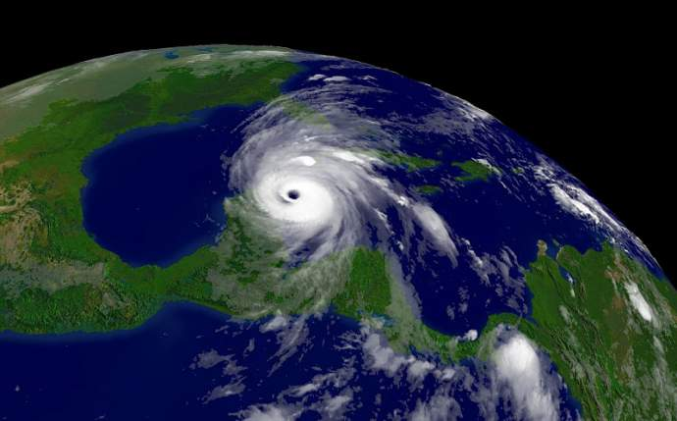
Source: CENAPRED (2011).
(ii) Hurricane Stan Over Mexican Territory
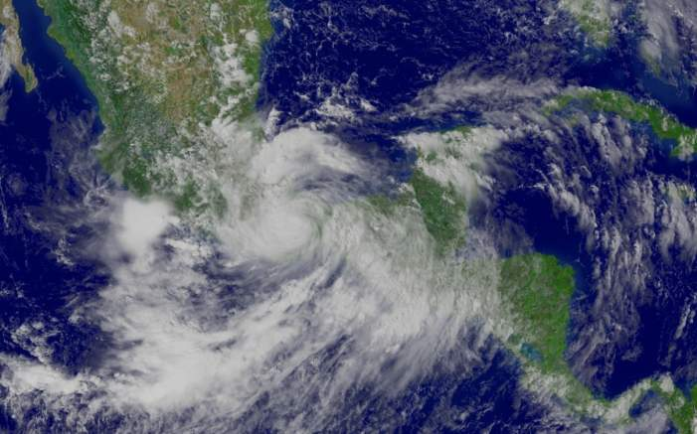
Source: CENAPRED (2011).

Mexico is also highly exposed to landslides, predominantly triggered by excessive rainfall. The most landslide-prone areas lie along the southern coast of the country, from the states of Chiapas to Guerrero, including the coasts of Jalisco, Veracruz, Tabasco, Puebla, Hidalgo, Guanajuato, the northern part of Baja California, and Mexico City. The states of Sinaloa, San Luis Potosí, Durango, Zacatecas and Nuevo León are also exposed to landslides, although to a lesser extent.
Many disasters have affected Mexico in recent history. Between 1999 and May 2011 alone, the country experienced 171 disasters. Table 2.1 provides a breakdown of these events by type of hazard and Figure 2.3 indicates the extent of severity of exposure to each hazard type relative to total geographic area.

Table 2.1. Main Types and Number of Disasters in Mexico (1999-2011)
Type of Disaster | Number of disasters
Drought | 5
Earthquake (seismic activity) | 19
Epidemic | 3
Extreme temperature | 14
Flood | 46
Mass movement (wet) | 10
Storm | 64
Volcano | 8
Wildfire | 2
Total | 171
Source: EM-DAT: The OFDA/CRED International Disaster Database, www.emdat.be - Université Catholique de Louvain - Brussels – Belgium. As of May 2011.

Figure 2.3. Percentage of Geographic Area in Mexico Exposed to Natural Hazards.
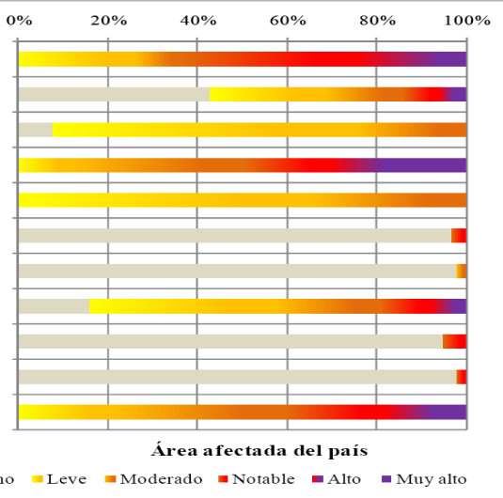

- None Low Moderate Notable High Very High

Source: Inter-American Development Bank’s Disaster Risk Indicators, 2010, http://idbdocs.iadb.org/wsdocs/getdocument.aspx?docnum=35160020, Original Source (MunichRe, http://mrnathan.munichre.com (2010).

Vulnerability to Natural Hazards
Over the past few decades, Mexico has achieved extensive economic development and a significant expansion in public infrastructure. Unfortunately, this success has also increased exposure to natural hazards. The recent growth in the incidence of disasters is mainly due to the increasing concentration of population and assets in hazard-prone areas.
As shown in Table 2.2, a large proportion of Mexico’s territory and population is subject to a variety of natural hazards. For instance, 41 percent of Mexico’s territory and 27 percent of its citizens are exposed to storms, hurricanes, and floods.
Table 2.2. Mexico’s Hazard Profile – Exposure of Land and Population to Specific Hazards
Phenomena | Exposed area |  | Exposed population
 | Km² | As % of national territory | Millions | As % of total population
Storms, hurricanes, floods | 815,353 | 41 | 31.3 | 27
Earthquakes | 540,067 | 27 | 31.0 | 27
Droughts | 573,300 | 29 | 21.2 | 19
Fires | 747,574 | 37 | 28.4 | 25
Source: CENAPRED (2010).
Mexico has a total population of 112 million. Although Mexico’s territory expands over almost two million square kilometers, the population is largely concentrated in cities. Rapid urbanization has increased the growth and density of housing and public infrastructure in these areas. Around 75 percent of the population currently lives in urban areas, with a tendency for lower income households to reside in more hazard-prone locations. With over 21 million inhabitants in Mexico City and its metropolitan area alone, this major urban center represents the highest concentration of risk in Latin America. See Annex 3 for data on population growth by state.
The growth in population and assets in Mexico has increased the potential scale of disaster losses at both the federal and state levels. States such as Veracruz, Jalisco, and Mexico, among others, have pockets of high population density and face significant potential disaster losses. Figure 2.4 illustrates the geographic concentration of several types of public asset in Mexico.

Figure 2.4. Sample Images of Geographic Location and Density of Public Infrastructure in Mexico
Location of medical units under the responsibility of Mexico’s Ministry of Health  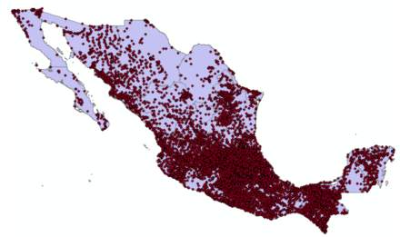 | Location of hospitals and health centers under the responsibility of Mexico’s Ministry of Health  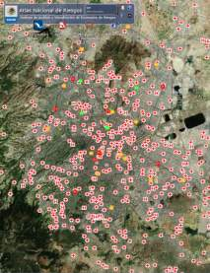
Location of middle and high schools under the responsibility of Mexico’s Ministry of Education  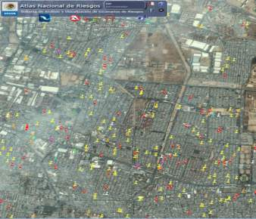 | Location of elementary schools under the responsibility of Mexico’s Ministry of Education  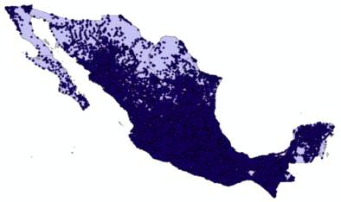
Location of bridges in Mexico’s territory  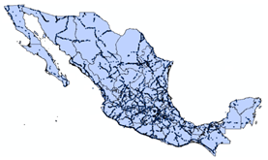 | Location of highways in Mexico’s territory  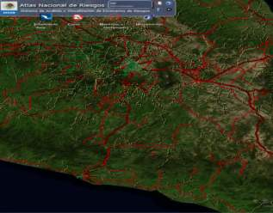
Source: RMS (2008).

Brief History of Civil Protection and Disaster Management in Mexico
The Mexico City earthquakes of September 19 and 20, 1985, with magnitudes of 7.8 and 7.3 respectively on the Richter scale, marked a shift in disaster risk management in Mexico. More than 20 million people in Mexico felt these tremors. The earthquakes killed 6,000 people and generated direct and indirect losses totaling an estimated US$4.1 billion at 1985 prices (CENAPRED 2000). Damage to infrastructure accounted for approximately 87 percent of the losses. The remaining 13 percent comprised loss of income or production, increased costs of service provision, emergency response and temporary rehabilitation. Nearly 1,700 schools were damaged and 30 percent of the hospital capacity in Mexico City was destroyed. Approximately 250,000 people became homeless and nearly 900,000 residents were left with damaged homes. These earthquakes triggered an immediate interest in improving the country’s capacity to manage disaster risks.
Following the earthquakes, the Federal Government of Mexico took steps both to support post-disaster reconstruction needs and to strengthen the civil protection system. A National Commission for Reconstruction was established in October 1985 under the leadership of the incumbent Mexican President, President Miguel de la Madrid, as an initial step to address the needs of the affected populations. The Commission was also requested to establish the necessary mechanisms, systems, and organizations to better assist populations affected by future disasters. These initial activities built on the experience of public institutions, non-governmental organizations, the private sector and the scientific community.
A study on the creation of a National System of Civil Protection was published in the Official Journal of the Mexican Federation on May 6, 1986. This study defined the mandate of civil protection: namely, to protect the individual and society in the event of a natural or man-made disaster by reducing or preventing loss of human life, destruction of property, damage to nature, and disruption of lifeline public services. Known as the Sistema Nacional de Protección Civil (SINAPROC), the subsequent National System of Civil Protection was created as an organized group of structures, functional relations, methods and procedures involving all levels of government and engaging with the private sector and non-governmental and civil society organizations.

According to Mexico’s Law of Federal Public Administration, the Ministry of the Interior is the federal institution responsible for coordinating and supervising the National System of Civil Protection. As such, the Ministry of the Interior, through the General Coordination of Civil Protection, is the agency responsible for managing the mechanisms and policies for the prevention of disasters and post-disaster response and reconstruction activities. The functional and coordinating roles between this and the various other offices and agencies responsible for civil protection at all levels of government in Mexico are depicted in Figure 2.5.

Figure 2.5. Flow Chart of the Civil Protection System in Mexico
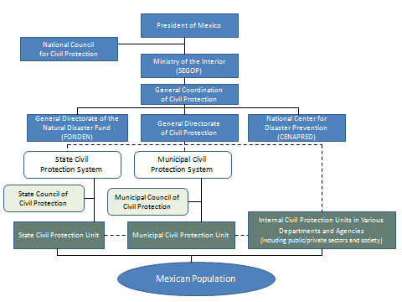
Source: Mexican Civil Protection (2010).

In terms of approach, disaster risk management in Mexico is broadly defined as the process of planning, participation, intervention, decision-making and sustainable development policies aimed at: (i) understanding the causes of risks; (ii) controlling risks and risk reduction; (iii) countering the societal creation of associated risks; and (iv) strengthening the resilience of government and society against natural disasters. This entails a multidisciplinary approach and a strong commitment from all levels of government and society as a whole. The Mexican Government has made disaster risk management a national priority and integrated it into the country’s planning processes. It has strengthened the capacity of national and local institutions to reduce ex ante risk, to plan for potential disasters and to respond efficiently in the event of an adverse natural event. The Government also applies disaster risk management as a tool to address climate change adaptation by strengthening resilience to climatic extreme events.
In 1996, the Government of Mexico introduced a Natural Disaster Fund (Fondo Nacional de Desastres Naturales), commonly known as FONDEN. FONDEN’s mandate is to ensure that adequate financial resources are immediately available in the aftermath of a natural disaster to finance the reconstruction of public infrastructure and low-income housing without compromising existing budgetary plans and approved public programs. As an inter-institutional financial vehicle, FONDEN was established as a line item (line 23) in the annual Federal budget.
FONDEN has evolved significantly since its creation. The Government of Mexico has introduced various changes to its operating rules and procedures to improve the overall efficiency of its resources and several additional windows have been created under FONDEN to strengthen disaster risk management further. All changes are published in the Official Diary of the Mexican Federation. Of particular note, budget shortfalls for post-disaster reconstruction purposes led to the introduction of a new law in 2006 which requires the Ministry of Finance to commit a fixed percentage of its annual budget to FONDEN and certain other disaster-related programs under the FONDEN budget line. According to Article 37 of Mexico’s Federal Budget Law, the annual allocation for the FONDEN Program, FOPREDEN and the Agricultural Fund for Natural Disasters (Componente de Atención a Desastres Naturales en el Sector Agropecuario y Pesquero- CADENA) together with the uncommitted funds in the FONDEN Trust at the end of the previous fiscal year cannot be less than 0.4 percent of the total Federal budget (approximately US$800 million per annum). On average, 87 percent of this appropriation goes to FONDEN. Further significant changes were made at the end of 2010, simplifying FONDEN’s procedures and streamlining reconstruction activities by concentrating responsibility for reconstruction within the federal agencies, rather than spreading them across both federal and state agencies. Box 2.1 below describes the key dates in the evolution of FONDEN. Further details on the current structure, nature and role of FONDEN and related legal and institutional arrangements are provided in Chapter 3.
Box 2.1. Key Dates in the Evolution of FONDEN
1985: Soon after the devastating earthquakes in Mexico in September, the National Commission for Reconstruction is created to conduct a study on the establishment of a national system of civil protection.
1986: The Official Diary of the Federation publishes the study on “Basis for the Establishment of the National System of Civil Protection” in May.
1988: The Vice Ministry of Civil Protection, Prevention and Social Recovery and the General Directorate of Civil Protection are created in the Ministry of Interior, which is mandated to establish the mechanisms, systems, and organizations to better assist populations affected by future disasters.
1996: Mexico’s Natural Disaster Fund, FONDEN, is created as a line item in the Federal Budget (Budget line 23 of the ‘Economic Provisions’ budget) to ensure that resources are made available to efficiently finance the post-disaster reconstruction and restoration of damaged public infrastructure, low-income housing and forestry, protected natural areas, rivers, and lagoons. The program is introduced as a budgetary instrument administered by the Ministry of Finance.
1999: A first set of rules is established to provide general guidance on damage assessments and access to FONDEN resources, including regulations on the mechanisms, requirements, procedures, milestones, and deadlines to be met by state and federal agencies. The Federal FONDEN Trust is established. The Ministry of Interior becomes the coordinator of FONDEN and the entity in charge of issuing and publishing declarations of natural disasters.
2000: FONDEN’s operating procedures are modified to include emergency declarations and the establishment of sector committees to support damage assessments. Representatives from both federal and state governments are designated to participate in joint damage assessments to determine the level of FONDEN resources required in response to eligible disaster events. Legal agreements are also established with each of the 32 state governments, creating state trust accounts to hold FONDEN resource allocations for specific disasters.
2002: The Natural Disasters Preventive Trust, FIPREDEN, is created under Article 32 of the General Law of Civil Protection to support federal agency and state government preventive actions in case of imminent and potentially adverse events that could not have been foreseen.
2003: The Fund for Natural Disaster Prevention, FOPREDEN, is created through Decree Sections 3 and 4 of the General Law of Civil Protection to support federal agency and state government investments in risk identification and risk reduction. The Ministry of the Interior is designated responsibility for the coordination of this Fund.
2004: FONDEN’s operating rules are revised to give state governments a more prominent role in accessing post-disaster resources. The new rules indicate that the Fund’s resources will be made available to state governments within 23 working days.
2006: A new Federal Budget Law is approved to address the regular shortfall in FONDEN’s budgetary resources. Article 37 of Mexico’s Federal Budget Law requires the Ministry of Finance to commit an annual percentage (no less than 0.4 percent) of its annual federal budget to FONDEN and related activities. Additional modifications are made to FONDEN’s rules to simplify its allocation approval process and thereby further expedite resource authorizations. FONDEN issues the world’s first government catastrophe (cat) bond, Cat MEX, with coverage against earthquakes for a three-year period.
2009: Further reforms are adopted to expedite approval of FONDEN resources and a new mechanism is introduced to provide “Immediate Partial Support” (referred to as Apoyos Parciales Inmediatos – APIN) to finance urgent post-disaster actions while the full damage assessment and fund approval process is undertaken. These advance payments are later reconciled with the approved allocation. With assistance from the World Bank, FONDEN issues a multi-cat bond, covering hurricane and earthquakes risks in specific regions of the country, to replace Cat MEX.
2010: FONDEN issues new rules and guidelines whereby federal agencies are assigned responsibility for the management of all federal and 50 percent of state infrastructure reconstruction works. FIPREDEN and FOPREDEN are merged into one single window for prevention. New operating rules are also announced for the preventive window in December 2010. Major disasters (including floods) affect several Mexican States, resulting in the approval of 58 requests for FONDEN support. A new Reconstruction Fund for State-level Governments is introduced on a pilot basis as part of Mexico’s 2011 federal budget.

Chapter 3: The Natural Disaster Fund FONDEN

This chapter provides an overview of Mexico’s Natural Disaster Fund, FONDEN. It also describes the evolution of FONDEN since its creation, reflecting efforts to continuously improve the Fund’s operating policies and procedures. The chapter concludes with a description of the innovative use of information and technology in disaster risk management in Mexico.

FONDEN’s Mandate and Scope of Activities
The Natural Disaster Fund, FONDEN, is a federal program and financial vehicle designed to provide resources for the recovery and reconstruction of damaged public assets and low-income housing in the aftermath of adverse natural events in Mexico. Anchored within Mexico’s National System of Civil Protection, its mandate is threefold. First, it finances emergency assistance to affected populations in the aftermath of a natural disaster. Second, it provides financial resources and executes the post-disaster rehabilitation and reconstruction of public infrastructure (including the restoration of forestry). Third, FONDEN provides financial support for the rehabilitation and reconstruction of low-income housing.
Various federal government agencies participate in the operation of FONDEN. Resources are available for the recovery and reconstruction of both federal and state infrastructure. The relevant federal and state entities must demonstrate that the magnitude of relief and reconstruction funding required exceeds their financial capacity in order to access resources. FONDEN does not provide direct support to municipalities. However, state governments have traditionally applied for FONDEN resources to restore municipal assets as appropriate when damaged by a natural disaster.

Box 3.1. Definition of Disaster under Mexico’s Civil Protection Law
Mexico’s Civil Protection Law defines disaster as: "....the state in which the population of one or more state entities suffers severe damage from the impact of a natural or man-made disaster calamity, resulting in loss of life, infrastructure or environment, in a way that disrupts the social structure and disturbs the essential activities of society, affecting livelihoods."
Source: General Civil Protection Law.
Table 3.1 lists the main types of natural events eligible for FONDEN support.
Table 3.1. Main Types of Adverse Natural Events Eligible for FONDEN Support
Geological:  - Avalanche;  - Volcanic eruption;  - Tsunami;  - Slope movement;  f) Extreme wave;  g) Earthquake;  h) Subsidence. | Hydrometeorological:  a) Severe hail;  b) Hurricane;  c) River flooding;  d) Rain flooding;  e) Severe rain;  f) Severe snow;  g) Severe drought;  h) Tropical storm;  i) Tornado | Other*:  a) Forest fire
* Damage resulting from any other natural phenomenon or weather situation with characteristics similar to the phenomena listed above, in terms of origin, frequency and severity of impact, can also be considered for FONDEN resources.

Source: FONDEN (2011).

FONDEN’s Financial Accounts
FONDEN is comprised of three primary financial accounts: (i) the FONDEN Program for Reconstruction; (ii) the FONDEN Trust; and (iii) the Revolving Fund. Following the devastating hurricanes and floods in 2010, a new account, entitled the Reconstruction Fund for Local Entities (Fondo de Reconstrucion de Entidades Federativas), was created to provide additional support to local entities, offering a line of credit for the post-disaster reconstruction of local infrastructure,. These instruments are designed to assist the Government of Mexico in its efforts to respond quickly and efficiently to emergency situations and to support post-disaster recovery and reconstruction.
As a public financial vehicle, FONDEN is financed through the Mexican Government’s annual federal budget. Article 37 of the Federal Budget Law stipulates that at the beginning of each fiscal year the federal government should allocate no less than 0.4 percent of its annual federal budget for FONDEN, the preventive fund FOPREDEN and the Agricultural Fund for Natural Disasters . This amount is net of uncommitted funds for the previous fiscal year in the FONDEN Trust. In 2011, US$800 million was approved for the FONDEN Program for Reconstruction and disbursed through the FONDEN Trust.
Box 3.2. Preventive Fund FOPREDEN
The two preventive windows, referred to as FIPREDEN and FOPREDEN, were merged into one single window for prevention called FOPREDEN in 2010. The Preventive Trust, FIPREDEN, became the financial arm of the new FOPREDEN, financing all prevention projects.
At the end of each fiscal year, 20 percent of uncommitted funds in the FONDEN Program for Reconstruction are transferred to the Preventive Trust. In addition, FORPREDEN receives an ordinary budget allocation each year through line 23 of the Federal Budget (amounting to around US$ 25 million). This allocation is transferred to the Preventive Trust over the course of the budget year, as and when needed to finance approved project. Under the 2010 changes in operating rules, the new FOPREDEN can also receive extra funds from the FONDEN Program or the FONDEN Trust if needed. Conversely, uncommitted funds can be transferred from FOPREDEN into FONDEN if additional resources are needed for post-disaster activities. Any funding remaining in FOPREDEN’s ordinary budget (line 23) allocation at the end of the fiscal year are transferred to the Preventive Trust to build reserves, rather than reverting to the Federal Treasury.
FIPREDEN operates like the FONDEN Trust, whereby project proposals can be presented throughout the year. A Technical Committee (similar to the FONDEN Trust Technical Committee) reviews and approves risk reduction proposals and Banobras acts as the Trust’s fiduciary agent.
Preventive actions financed by the new FOPREDEN focus on: (i) the identification and assessment of hazards, exposure, vulnerabilities and risks; (ii) ex ante disaster risk reduction and mitigation activities; and (iii) local community capacity building efforts around disaster prevention. Local Risk Atlases or Risk Maps are used as a starting point to present new preventive projects, meaning that in order to submit a new preventive project to be financed by FOPREDEN, is mandatory that the State has already a Risk Atlas; if not, they need to submit as their first project to be financed by FOPREDEN the construction of a Risk Atlas and then present another type of preventive project. So far, FOPREDEN has concentrated on four key areas: (i) improvements in public infrastructure during reconstruction (“build back better”), (ii) financial risk transfer instruments, (iii) local state funds; and (iv) the provision of specialized equipment to enable federal entities to strengthen disaster response at the local level.
The Federal Budget Law does not define how FONDEN’s annual budget allocation will be managed within FONDEN. FONDEN is responsible for allocating resources for post-disaster recovery and reconstruction activities in accordance with its operating rules. Any funds that are unutilized at the end of the fiscal year remain in the FONDEN Trust as reserves for use in subsequent years.
If the resources allocated to FONDEN are exhausted or insufficient, Article 19 of the Federal Budget Law allows for additional, exceptional budget allocations to be made. In such cases, resources from the federal budget surplus, if any, are allocated to FONDEN. To date, Mexico’s oil revenue surplus has been the main source of additional resources for FONDEN. When there is no excess revenue in a given fiscal year, Article 32 of Mexico’s Civil Protection Law stipulates that the Ministry of Finance should seek transfers from elsewhere and secure multiple sources of funding or savings from other programs to provide FONDEN with sufficient financing to cope with natural disasters. See Figure 3.1 for a summary of each FONDEN instrument and its purpose and Figure 3.2 for more details on activation triggers and timing of resource allocations.
Figure 3.1. Overview of FONDEN’s Financing Instruments.
Source: FONDEN (2011).

Figure 3.2. Role of FONDEN’s Instruments in Mexico’s National System of Civil Protection.
Source: FONDEN (2011).

FONDEN Program for Reconstruction
The FONDEN Program for Reconstruction aims to provide financial support for the reconstruction of public infrastructure and (uninsured) low-income housing damaged as a consequence of a natural disaster. Financial resources are also made available through this program for the restoration of forestry, protected natural areas, rivers, lagoons, and other natural resources.
The program is intended to fill the gap between the resources originally earmarked by state and federal entities for post-disaster response purposes and the actual funding required. FONDEN provides resources for state and federal entities to meet disaster response and recovery needs that extend beyond their operational and financial capacity. FONDEN finances 100 percent of the recovery and reconstruction costs for eligible damaged infrastructure at the federal level and manages the reconstruction efforts through the relevant federal agencies. It provides up to 50 percent of the total cost for reconstruction of damaged infrastructure at the state level, with related activities executed by the federal entities responsible for each of the affected sectors. State governments finance the remaining 50 percent of reconstruction costs through their own budget resources or via a line of credit made available through the newly established Reconstruction Fund for Local Entities (see below). Municipal governments and local agencies can also benefit from FONDEN resources. In this case, the relevant state government requests and manages the FONDEN support on their behalf.
In 2009 a new financing mechanism was introduced under FONDEN’s Program for Reconstruction known as ‘Immediate Partial Support’ (Apoyos Parciales Inmediatos - APIN). This mechanism provides partial financial support immediately after a disaster to finance urgent post-disaster actions and needs while the full damage assessment and fund approval process is completed. APIN resources are authorized by the Ministry of Finance within 24 hours of the receipt of a request for support from a federal or state entity and are made available through the FONDEN Trust. Requests are met in full and the advance payments are later reconciled with the total approved FONDEN allocation. In the case of state support, if APIN disbursements exceed 50 percent of the total agreed cost of reconstruction at the state level, then this over-payment is returned to the FONDEN Trust. This procedure allows FONDEN to provide resources to meet urgent needs in the immediate aftermath of a disaster whilst maintaining its cost-sharing arrangement with state governments. See Box 3.3 and Annex 12.
Box 3.3. Immediate Partial Support
Immediate resources are available to support the implementation of urgent activities in the aftermath of a disaster. These resources are most commonly used for the provisional restoration of lifeline infrastructure such as communications and other utilities, removal of debris, rental of heavy machinery, and other activities that help to normalize the situation in the affected areas. This financing component provides the required funds quickly during or immediately after a disaster so that the necessary actions can be taken to protect the population and avoid additional damage to public infrastructure.
To provide additional support to local entities, FONDEN introduced a new Reconstruction Fund for Local States following devastating hurricanes and floods in 2010. This Fund offers lines of credit to state governments to help them cover their share in the reconstruction costs following a disaster. Eligible states pay the interest on the loan principal and the Fund pays the principal at the end of the 20-year credit period.

The FONDEN Trust
The purpose of the FONDEN Trust is twofold: (i) to facilitate the provision of federal resources to finance activities approved by its Technical Committee for the reconstruction of public infrastructure and low-income housing following a disaster, and (ii) to act as FONDEN’s financial vehicle and to leverage private capital through disaster risk transfer instruments such as insurance and catastrophe (cat) bonds.
The trust account is managed by Banobras, Mexico’s national development bank for public works and services, which acts as a fiduciary agent and trustee of the Federal FONDEN Trust. When financial resources are required for reconstruction activities approved by the FONDEN Trust Technical Committee, the FONDEN Trust transfers funds directly to the accounts of the relevant public works contractors and/or suppliers and providers of goods and services, for and on behalf of the executing agencies. In accordance with the “Specific Operating Guidelines for the Natural Disaster Fund” published on January 31 2011, the FONDEN Trust acts as a cash transfer mechanism to finance post-disaster reconstruction activities prior to the submission of invoices and other documentation by implementing entities. Payments from the FONDEN Trust to the Federal agencies or service providers are based on directions received from the FONDEN Trust Technical Committee. This committee is chaired by Mexico’s Ministry of Finance and meets every trimester, although additional meetings can be called as necessary. Table 3.2 lists the members of the FONDEN Trust Technical Committee and respective voting authority of each of its representatives at the federal level. Annex 5 lists the members of the FONDEN Trust Technical Committees at both the federal and state level.
Table 3.2. Members of the FONDEN Trust Federal Technical Committee and Voting Authority
FONDEN Trust Technical Committee (Federal Level)

Federal Government Representatives* and Authority

Two Representatives of the Ministry of Finance | Voting Power
Representative of the Ministry of Interior (SEGOB) | Voting Power
Representative of the Ministry of Civil Service | Observer Status  (No Voting Authority)
Representative of the FONDEN Trust (Permanent invitation with mandatory attendance required at all Technical Committee meetings) | Observer Status  (No Voting Authority)
* All representatives designate an alternate to ensure participation.
Source: FONDEN (2011).
In addition to the financing of post-disaster reconstruction activities, the FONDEN Trust can provide resources for preventive projects by transferring resources to the Natural Disasters Prevention Fund (FOPREDEN) and also can be used for the provision of risk transfer instruments, such as insurance.
Prior to 2011, FONDEN’s rules mandated that Federal FONDEN Trust funds allocated for the reconstruction of local-level infrastructure should be transferred to State FONDEN Trusts once approved. These funds were then disbursed to state agencies, service providers, and municipalities as appropriate. In some instances, however, difficulties arose in securing the 50 percent state counterpart financing contribution, as required in order to receive for FONDEN support, leading to significant delays in post-disaster reconstruction. Since 2011, new operational guidelines therefore require federal agencies to manage up to 50 percent of works relating to the reconstruction of state-owned infrastructure drawing directly on resources from the FONDEN Trust and FONDEN Trust resources are no longer transferred to the states. Individual states are responsible for financing the remaining 50 percent of reconstruction needs, using either their own resources or drawing on a line of credit from the new Reconstruction Fund for Local Entities.

FONDEN’s Revolving Fund
In addition to its core funding mechanisms, FONDEN has a small flexible financial instrument, referred to as the Revolving Fund or the Immediate Fund, to support emergency activities in the immediate aftermath of a disaster. The Revolving Fund provides resources for the acquisition of emergency relief supplies.
This mechanism allows FONDEN to provide humanitarian assistance directly to affected populations through local service providers before, during, and after a disaster. The assistance includes food, medical supplies, articles for temporary shelter (such as blankets and mattresses), search and rescue equipment and a few additional products.
The Revolving Fund is managed within the Ministry of the Interior through Mexico’s National System of Civil Protection . It operates under its own operating rules, governed by the “Agreement establishing the guidelines for issuing declarations of emergency and the use of the Revolving Fund” as published in the Official Journal of the Mexican Federation on December 31, 2008.
A declaration of emergency is required to access resources from the Fund (see Box 3.4). Once the emergency declaration is issued, state governments can request urgent support from the Revolving Fund. These requests must include a justification of the products and services requested and an indication of the number of people who would be supported. The Directorate General of FONDEN considers the validity of these requests under the criteria issued by the General Coordination of Civil Protection. If approved, the Directorate General of FONDEN submits the requests to the Directorate General of Resources, Materials, and General Services (DGRMSG) of the Ministry of the Interior. The DGRMSG fulfills the requests, procuring the goods and services and delivering them to the relevant states for distribution to the affected populations in municipalities under the declared state of emergency. The invoices, containing a detailed breakdown of the products ordered and delivered, are submitted to the Directorate General of FONDEN. Delivery notices are also included, providing a breakdown of all products received. These invoices are then sent to the Ministry of Finance. The Ministry of Finance determines whether the invoices will be paid from FONDEN Program or the FONDEN Trust. Since 2010, all emergency supplies and services have been paid through the FONDEN Trust. FONDEN’s fiduciary agent, Banobras, transfers the approved funds directly to the suppliers and service providers.
The Revolving Fund is financed through the annual budget appropriation for FONDEN’s Program for Reconstruction. However, it is replenished with resources from the FONDEN Program or FONDEN Trust once fully used. Although the Revolving Fund has its own operating rules, all expenses are now paid by the FONDEN Trust. Since its inception, it is estimated that allocations to the Revolving Fund have averaged less than 10 percent of the total resources used for FONDEN’s post-disaster activities.
Figure 3.3. Activation Triggers and Timing of FONDEN’s Resource Allocations
* All federal plans and programs are activated for disaster response once triggered.
Source: FONDEN (2011)

FONDEN Operating Guidelines
The Ministry of the Interior is responsible for the coordination of the overall post-disaster reconstruction process. It issues emergency and disaster declarations, announces these declarations in the official newspaper, and coordinates the allocation of FONDEN resources. It also monitors the post-disaster reconstruction of both federal and local infrastructure to ensure proper use of these resources. The overall process for accessing FONDEN support and executing related activities can be summarized in four main phases:
- Declaration of disaster;
- Damage assessment and request for FONDEN resources;
- Disbursement of resources and implementation of post-disaster activities;
- Dissemination of the report on post-disaster activities.
Figure 3.4 summarizes the initial steps in accessing FONDEN resources and Figure 3.5 summarizes operational aspects as described in further detail below. Refer to Annex 6 for an overview of FONDEN’s previous fund allocation process and Annex for additional information on FONDEN’s new procedures. Annex 8 provides two practical examples of the step-by-step actions taken to access FONDEN resources following two actual disaster events in 2010.
Note that continuous changes are made to FONDEN’s operational policies and procedures to increase the efficient application and effective use of resources.
Figure 3.4. Declaration of a Natural Disaster and Initial Steps to Access FONDEN Resources
Source: Secretaría de Gobernación (2009).
Figure 3.5. Process to Access FONDEN Resources for Post-Disaster Reconstruction
Source: SHCP (2011).

Phase 1: Request for Declaration of Natural Disasters
A declaration of natural disaster must be issued by the Ministry of Interior in order to access FONDEN financing for post-disaster reconstruction. In the absence of this declaration, any requests for reconstruction funding by state or federal entities are deemed ineligible.
The Governor(s) of the affected State(s) must request the pre-assigned technical federal agency to confirm the occurrence of a disaster within three days of an event. As a general rule, FONDEN resources cannot be approved for local infrastructure without this initial request. However, in the aftermath of a natural disaster, affected federal agencies requiring FONDEN resources also coordinate with the authorities at the local level to ensure that municipalities with damaged infrastructure in their respective sectors have been included in the Governors’ requests. In the event that certain municipalities have been omitted, the head of a federal entity can directly request the technical agency to include the concerned municipalities in its deliberations.
The technical agency focuses its analysis on the severity of the natural phenomena according to parameters defined by FONDEN rules and does not assess damage. Table 3.3 summarizes the technical agencies involved and the types of adverse natural event that fall within their respective areas of responsibility.
Table 3.3. Areas of Responsibility for Technical Agencies
Pre-assigned Technical Agencies | Confirmation of the Occurrence of a Severe Natural Phenomena by Type
National Water Commission (CONAGUA) | Hydrometeorological Phenomena
National Forestry Commission (CONAFOR) | Forest Fires
National Center for Disaster Prevention (CENAPRED) | Geological Phenomena

Box 3.4. Mexico’s Law on Emergency and Disaster Declarations
Articles 29-37 of Chapter VI of the Mexican General Law of Civil Protection specify the requirements for declarations of emergency and disaster. Originally published in the Official Journal of the Mexican Federation on May 12, 2000, the last reforms were made in April 2006.
In case of an imminent disaster threatening human life and requiring immediate action by the National System of Civil Protection, the Ministry of the Interior can issue a declaration of emergency, which is then disseminated through the mass media. The Ministry of the Interior must then allocate resources from the Revolving Fund to mitigate the effects of the potential disaster and to respond immediately to urgent ensuing needs.
The Ministry of the Interior can declare a disaster if one or more adverse events have caused severe damage in excess of local response capacities. Applications for the declaration of a disaster can be submitted to the Ministry of the Interior by (i) state governments, where disaster response and recovery needs extend beyond their operational and financial capacity, and/or (ii) Federal agencies and line ministries. Once the application has been received, the Ministry of the Interior has 12 calendar days to publish the declaration of natural disaster in the Official Journal of the Mexican Federation. State government entities have 30 calendar days from the day the disaster declaration is published to access FONDEN’s financial support.

Box 3.5. Frequency of disaster declarations
Every year Mexico experiences a number of natural disasters resulting in the declaration of a disaster. There were a total of 58 disaster declarations in 2010, compared to only 19 in 2009. However, the number of disasters experienced in any given year is not necessarily indicative of the scale of disaster impact since the latter depends on the location, magnitude and geographical scale of each event.
Declarations of Natural Disasters in Mexico by Year, 1999-2011
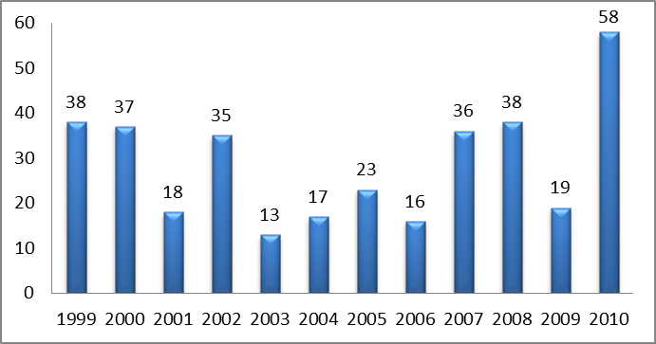
Source: FONDEN (December 2011)
The number of disaster declarations also varies considerably between states. Since 1999, the state of Veracruz has had 48 declarations of disaster alone, compared to five or less for each of eleven other states. See Annex 5 for a list of disaster declarations by Mexican States in 2009.
Declarations of Natural Disasters by Mexican States (1999- 2011)
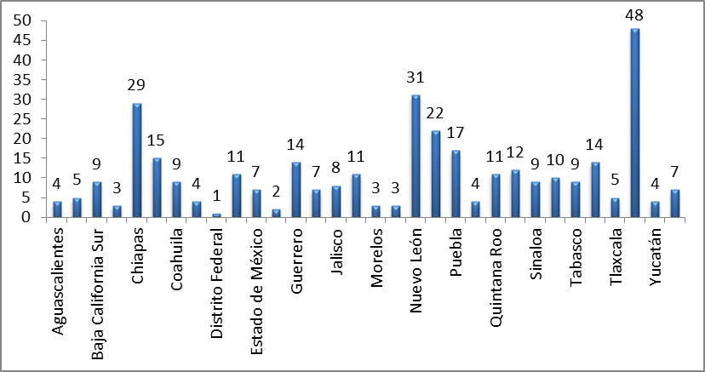
Source: FONDEN (December 2011)

Phase 2: Damage Assessment and Requests for FONDEN Resources
Confirmation of the Disaster Occurrence and the Role of the Damage Assessment Committee

A Damage Assessment Committee is established within 24 hours following written confirmation by the relevant technical agency that a severe natural phenomenon has occurred in at least one municipality. In parallel and at the same time, the affected federal and state entities must file an application for the declaration of a natural disaster. According to FONDEN rules, this declaration should be issued by the Ministry of the Interior and published in the Official Journal of the Mexican Federation no later than four working days from the time of the request, whether or not the damage assessment process has been completed.
At the opening session of the Damage Assessment Committee, officials from federal and local agencies meet to initiate the assessment. Sub-committees are formed for each affected sector, such as housing, roads and bridges, hydraulic infrastructure, urban infrastructure, education, health and so on.
Field work and site visits are then expeditiously conducted to assess the damage. Members of the Damage Assessment Committee work to identify affected public infrastructure and to determine the extent of damage. Affected municipal government assets are also verified. Each sector team has ten working days from the date of establishment of the Damage Assessment Committee to assess the damage and confirm the resources needed for reconstruction. This period can be extended by an additional ten working days in exceptional circumstances. Requests for funding must be based on a detailed damage assessment and identify each infrastructure program requiring financing.
Table 3.4. Members of the Damage Assessment Committee
Members of the Damage Assessment Committee

Federal Government Representatives | State Government Representatives
Representative of the Ministry of Interior (SEGOB) | The State Governor who acts as Chairman of the Damage Assessment Committee (or a representative with delegated authority)
Representative of the Policy and Budget Control Unit (UPCP) of the Ministry of Finance | Representative of the Ministry in charge of Finance (or the Budget and Public Expenditure)
One Representative of Each Affected Federal Ministry and Agency | Representative of the Civil Protection Unit
Additional Representatives (where applicable):  - The Unit of Insurance, Pensions, and Social Security of the Ministry of Finance  - The Responsible Technical Body | Representative of Local Control Authority
Source: FONDEN (2011).
Requests for FONDEN Resources
In order to apply for FONDEN resources, both federal and state agencies must demonstrate that the scale of relief and reconstruction requirements exceeds the resources earmarked in their programs to manage natural disasters.
Within seven days from the date of installation of a Damage Assessment Committee, federal and state agencies may request Immediate Partial Support, commonly referred to as “APIN”, for the implementation of urgent activities relating to the restoration of federal and local communications and lifeline infrastructure, such as debris removal, equipment and heavy machinery rental, rental of classrooms, and other interim steps. The Ministry of Finance has 24 hours to consider and approve these requests. The public bank Banobras acts as the fiduciary agent and notifies relevant federal and state entities that resources are available through the FONDEN Trust for the authorized actions.
At the results meeting of the Damage Assessment Committee, each sub-committee presents its findings on the identification and quantification of damage and related reconstructed needs. Critical information and evidence must be provided for each sector including: (i) geocoded photographs documenting the type of damage to each affected asset in all of the municipalities under the disaster declaration; (ii) itemized reconstruction needs and related costs; and (iii) proposed improvements as part of the reconstruction work to mitigate and even prevent future disaster damage (“build back better”), related costs and a comparison of these costs with the replacement cost of each public asset.
Within seven days of the results meeting, each federal agency must deliver its final diagnosis for its sector of responsibility (covering both federal and local assets) to the Directorate General of FONDEN of the Ministry of the Interior.
Within a further two days of receipt of these documents, the Directorate General of FONDEN should:
- Verify that there is no duplication of effort among the federal and state entities;
- Verify that the requested resources are only intended to address damage caused by the disaster (and not pre-existing damage);
- Verify that each item of damaged infrastructure has not previously received any reconstruction financing from FONDEN. If any have, lower levels of support will be made available for those items, in accordance with FONDEN’s predetermined schedule for such eventualities (see Box 3.6);
- Develop and submit to the Ministry of Finance a consolidated request for funding for all damaged sectors, including the Ministry of the Interior’s opinion on whether the application complies with FONDEN’s requirements for resource authorization.
Once the Ministry of Finance receives this request, it has five days to convene a meeting of the FONDEN Trust Technical Committee to authorize the resources for post-disaster reconstruction.

Phase 3: Disbursement of Resources and Implementation of Reconstruction Activities
Since January 2011, when the FONDEN Specific Operating Guidelines were issued, federal agencies have been solely responsible for the execution of all FONDEN-supported rehabilitation and reconstruction activities using their own operating procedures. Federal agencies are responsible for the design, contracting and supervision of all rehabilitation and reconstruction works and are required to submit regular progress reports to FONDEN using a standardized template. The FONDEN Trust Technical Committee monitors the implementation of activities. If any approved FONDEN funds are not used or any reconstruction activities cancelled, the funds are released into the Federal FONDEN Trust for use in further disaster events. See Figure 3.9.
Reconstruction of Local Infrastructure
The Ministry of the Interior and the Ministry of Finance sign an agreement with each state to coordinate the reconstruction efforts. All parties thereby agree that FONDEN will pay up to 50 percent of the total reconstruction expenses (including replacement and improvement costs) and that federal agencies or third parties will manage the implementation of the FONDEN-funded work. State-level entities are responsible for financing the remaining 50 percent of the reconstruction costs from their own resources and for executing this half of the local reconstruction efforts, as already noted. The agreement lists the reconstruction activities to be undertaken by the federal and local governments and the estimated execution periods in an annex. Within four working days following the delivery of the damage assessment reports, these annexes are signed by the relevant federal and local agencies responsible for executing the reconstruction activities.
The FONDEN resources are provided on the understanding that the execution of the reconstruction activities will be conducted drawing on state and municipal government resources as well, if not covered by federal resources. If local governments do not have sufficient resources to meet their 50 percent share, they can access resources from the newly established Reconstruction Fund for Local Entities.
Federal agencies are responsible for contracting service providers for the reconstruction works. They can contract a third party or agree to transfer some of the works to the state or municipality if they do not have sufficient capacity to undertake all of it.
Under the new operating procedures introduced in 2011, FONDEN resources stay in sub-accounts within the Federal FONDEN Trust. Payments are then made directly by Banobras, the fiduciary agent for the FONDEN Trust, from these sub-accounts to the federal agencies or third parties in charge of the reconstruction activities. Under previous rules, State FONDEN Trusts were used to receive resources from the Federal FONDEN Trust and local resources and state governments were held responsible for the federal-financed reconstruction activities. These State FONDEN Trusts will remain active until all previously supported reconstruction activities have been completed. Thereafter, each state government will decide whether to continue or dissolve the State Trusts.
Federal agencies must submit quarterly physical and financial progress reports to the Directorate General of FONDEN. These reports are reviewed by the FONDEN Trust Technical Committee.

Reconstruction of Federal Infrastructure
FONDEN pays for the reconstruction of eligible federal infrastructure in full, as already noted, and no counterpart funding is required. FONDEN approves the allocation of financial resources for post-disaster reconstruction activities to specific federal agencies as relevant – for instance, to the Ministry of Communication and Transportation (SCT) for road and bridge construction, the Ministry of Health (SSA) for hospital reconstruction, the Ministry of Education (SEP) for school reconstruction, the National Water Commission for reconstruction of hydraulic infrastructure, and the Ministry of Social Development (SEDESOL) for low-income housing and urban infrastructure reconstruction. The relevant federal entities are directly responsible for the implementation of these reconstruction activities.
The FONDEN Trust’s fiduciary agent, Banobras, allocates the approved resources to the businesses contracted by the federal entities to undertake the work in accordance with their approved payment schedules. The relevant federal agencies submit quarterly reports on progress and financial status for examination during FONDEN Trust Technical Committee meetings.
Figure 3.9. FONDEN’s Resource Allocation Process for Post-Disaster Reconstruction
* The public bank Banobras acts as the Federal FONDEN Trust’ fiduciary agent under the supervision of the FONDEN Trust Technical Committee, chaired by the Minister of Finance or his representative. The FONDEN Trust holds funds in reserve once transferred from FONDEN’s Program for Reconstruction. Federal entities submit receipts to Banobras and the FONDEN Trust pays the contractors directly.
Box 3.6. Opportunities to Build Back Better
The FONDEN Trust Technical Committee can approve post-disaster reconstruction funding not only for the replacement but also for the improvement of damaged assets to strengthen their resilience against future hazard events (“build back better”). It is estimated that around 25 percent of approved FONDEN resources for post-disaster reconstruction finance risk reduction investments.
To further encourage both risk reduction and the implementation of a risk transfer strategy, FONDEN has established clear rules limiting repeat eligibility for FONDEN resources. FONDEN can only finance half of the reconstruction bill for eligible uninsured federal assets that have already received FONDEN support once before in the past (assuming the same assets remain uninsured) and 25 percent of the cost of reconstruction of eligible state assets. Thereafter, the assets are rendered ineligible for FONDEN support in the event of any further disasters. These rules apply to both federal and local assets. In contrast, insured assets are eligible for FONDEN funding (covering 100 percent of reconstruction costs for federal assets and 50 percent for local assets) irrespective of the number of times the assets have received reconstruction support from FONDEN in the past.
FONDEN share in total post disaster reconstruction costs
 | Insured federal asset | Insured local asset | Uninsured federal asset | Uninsured local asset
1st disaster | 100% | 50% | 100% | 50%
2nd disaster | 100% | 50% | 50% | 25%
3rd and subsequent disasters | 100% | 50% | 0% | 0%

Box 3.7. Significant Risk Mitigation Efforts in Mexico in Recent Years
Since the early 2000s when the Mexican Government began shifting from a primarily reactive civil protection system to a more preventive one, the government has emphasized risk reduction as part of its reconstruction efforts, as well as through the work of its prevention window, FOPREDEN. It has drawn on funding available from FONDEN and other sources for this purpose. Two examples focusing on severe flooding in the State of Tabasco and the impact of Hurricane Alex on the State of Nuevo León provide some useful insight on these “build back better” initiatives. Such initiatives are proving to be cost-effective in terms of avoided damage and losses.
EXTREME HYDROMETEOROLOGICAL EVENTS LEAD TO A COMPREHENSIVE WATER PLAN IN TABASCO
In October 2007, there were a number of tropical depressions and cold fronts in southeastern states and the Gulf of Mexico generating intense and continuous rains. The state of Tabasco was particularly severely affected. Tabasco experienced its worst flooding ever recorded, covering most of the state territory including the capital city, Villahermosa.
In the aftermath of the flood, Tabasco took immediate action to develop a Comprehensive Water Management Plan aimed at reducing the vulnerability of its population, economy, and ecosystems to extreme hydrometeorological events. The plan outlined a series of analytical studies and various structural investments, including emergency dam operations, reinforcement of levees, cleaning and dredging of channels and drains, building and reconstruction of dikes and protective walls, construction of floodways and other risk reduction investments. Some initial urgent steps identified under the plan were taken between November 2007 and the end of 2008, with MXN 1.8 bn (US$150 million) in funding from FONDEN and the Mexico’s National Water Commission (CONAGUA). Additional measures to a total value of MXN 2.8 bn (US$233 million) were implemented in 2009 and 2010 with further funding from CONAGUA. Some longer-term studies and activities to a total cost of MXN 4.8 billion (US$400 million) are now underway and should be completed by the end of 2012.
The benefits of these investments have become rapidly clear. In 2010 Tabasco experienced further climatic extremes, with cumulative rainfall for the year as a whole exceeding annual rainfall for 2007. Moreover, the state experienced monthly rainfall in excess of 550mm in two consecutive months in 2010, compared to only one month in 2007. Despite this, disaster-related damage and losses only reached 7.2 billion pesos (US$ 570 million) in 2010 compared to 32 billion pesos (US$2.9 billion) in 2007, a direct consequence of Tabasco’s efforts to strengthen its resilience to extreme hydrometeorological events.
HURRICANE ALEX AND RISK REDUCTION EFFORTS IN NUEVO LEON
FONDEN resources were used to complement CONAGUA’s regular programs to “build back better” in the State of Nuevo Leon in the aftermath of heavy rains and flooding caused by Hurricane Alex in 2010. Several hydrological, hydraulic, and geotechnical studies were conducted by education and research institutions to determine required river channel capacity and how best to reconstruct or develop new infrastructure to mitigate disaster risks. With this information, recovery and reconstruction activities were designed to significantly reduce and prevent future disaster-related damage. These activities included the restoration of a hydraulic section of the Santa Catarina River, channel dredging 27 kilometers of the Santa Catarina River, and the construction of approximately 4 kilometers of protective walls. CONAGUA has also built infrastructure to improve the protection of population centers in the Topo Chico Creek in Apodaca, Nuevo Leon. Extensive flood mitigation efforts were implemented in the municipality of Monterrey as well.

Phase 4: Dissemination of the Report on Post-Disaster Activities
Transparency is an important priority for FONDEN and efforts are made to ensure that FONDEN’s resource allocations and post-disaster reconstruction activities are carefully monitored and reported publicly. Real time information on FONDEN allocations for post-disaster reconstruction by disaster and sector are publicly disclosed through the Ministry of the Interior’s website. See Annex 9.

FONDEN’s Innovative Use of Information and Technology
The Government of Mexico employs the innovative use of information and technology across its full spectrum of disaster risk management activities. Ex post activities include the use of Geographic Information System (GIS) tools and devices to capture information in conducting post-disaster damage assessments. Automated systems and related technologies are applied to strengthen the control and transparency of FONDEN resources. Ex ante measures engage a broad community of users, including strong partnerships with academic institutions, to apply available technologies for disaster risk reduction and planning purposes. Figure 3.10 summarizes the primary methods, tools, applications, and user communities currently supporting Mexico’s disaster risk management activities.
Figure 3.10. Risk Modeling Methods and Tools for Disaster Risk Management in Mexico
Methods | - Hazard and Exposure Modules  - Probabilistic Analysis  - Risk and Loss Analysis Modules
Tools and Applications | - GeoNodes (Data Repositories)  - GIS and Visualization  - Maps and Applications  - Extensive Modular and API Centric
User Communities | - Open Access and Open Source  - Capacity Building Focus  - “Living Instruments”
Source: FONDEN (2011).

The use of geocoding to improve the accuracy of post-disaster damage assessments while also providing evidence of damage in each affected sector provides an example of FONDEN’s innovative application of technology. This process entails three key steps: (i) collecting information on the damaged infrastructure by using georeferenced photos; (ii) transferring the information online; and (iii) storing the information in FONDEN’s database for future reference and analysis.
Figure 3.11. Examples of Handheld Devices Used to Collect Information on Damaged Infrastructure

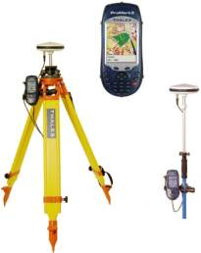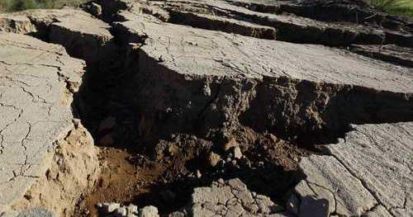

Collecting information on the damaged infrastructure by using georeferenced photos. As of April 1 2010, representatives of all affected agencies must submit at least four georeferenced photographs for each reconstruction work or activity as per FONDEN’s Rules of Operation. As part of the damage assessment process, members of the Damage Assessment Committee use handheld devices with GIS capabilities to collect information and take pictures, including details of the exact location of damaged infrastructure and the date. Each agency requesting FONDEN resources must ensure that the pictures are georeferenced and uploaded to FONDEN’s automated system for subsequent submission to the Damage Assessment Committee as evidence of the impact of the disaster in their respective sectors. These photographs are required for each activity seeking FONDEN support. They are complemented by polygons, which are created to show the affected areas visually, and by data quantifying the damage in each affected sector.
Capturing this information online. The Directorate General of FONDEN compiles these records into a validated system of requests for FONDEN resources and creates an inventory of post-disaster activities. Refer to Figure 3.12 for a diagram of FONDEN’s database.
Storing the information in FONDEN’s database. The pictures are compiled into a database for subsequent analysis of future risk reduction measures. The stored data are used regularly for information requests, the preparation of graphics and statistics, the calibration of loss models, the validation of public infrastructure that have been supported by FONDEN in the past and the identification of insured infrastructure.
Figure 3.12. Diagram of FONDEN’s Comprehensive Database
Database of Damaged Infrastructure
Database of Damaged Infrastructure
Database of Damaged Infrastructure



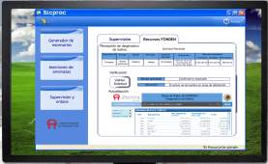

Source: FONDEN (2011)
This innovative application of satellite geo-referencing facilitates the expeditious collection and recording of data on the impact of disasters. The approach supports increased transparency and precision in the damage assessment process, while also avoiding duplication and reducing errors. See Figure 3.13 for a sample image with geo-referencing of damage caused by severe rain as presented to the Damage Assessment Committee.
Figure 3.13. Geo-referenced Image of Damage Caused by Severe Rain in Mexico
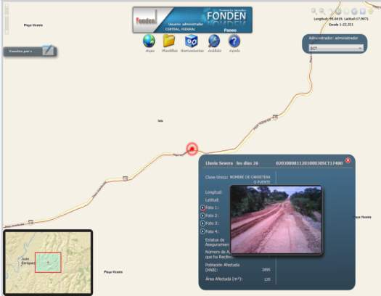

The National Centre for Disaster Prevention (CENAPRED), which plays a critical role in Mexico’s disaster risk management, also applies new technologies in its analysis of disaster risk. As the technical arm of Civil Protection, its primary objectives are to promote the application of technologies for the prevention and mitigation of disasters, provide technical training, and disseminate and promote preparedness and self-protection measures amongst at-risk populations. One of CENAPRED’s flagship initiatives is the National Risk Atlas.

Chapter 4: FONDEN Financial Management
This chapter reviews FONDEN’s financial disaster risk profile. It begins with a review of the historical impact of natural disasters on state and federal assets. It then analyses FONDEN’s financial disaster risk profile and describes the disaster risk financing strategy developed by FONDEN to manage its portfolio.

Disaster Risk Profile of Federal and State Governments
Both state and federal assets are exposed to natural hazards, and disasters can impose a significant burden on the public budget. Over the period 1999 to 2011, the cost of post-disaster reconstruction of public assets and low income housing averaged US$1,460 million per annum (in 2011 constant dollars), of which 77 percent related to local assets. The highest costs were incurred in 2010, when major floods generated post-disaster reconstruction needs exceeding US$5 billion. Local assets (including low income housing) accounted for two-thirds of this total.
Figure 4.1. Post-disaster reconstruction costs of federal and local assets (including low income housing), US$ 2011 constant dollars
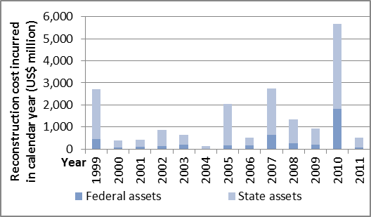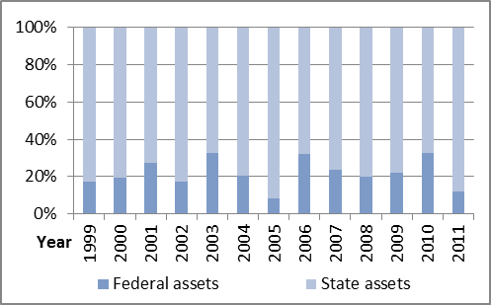
Source: Authors, from FONDEN (2011)
Under the FONDEN program, reconstruction costs are shared by the federal and state governments, as already noted. Over the period 1999 to 2011, the federal and state governments spent an average US$939 million and US$521 million (in 2011 constant dollars) respectively each year on reconstruction. The federal government accounted for 64 percent of total public reconstruction expenditure.

Figure 4.2. Post-disaster reconstruction costs paid by the federal government and state governments (in constant 2011 US dollars)
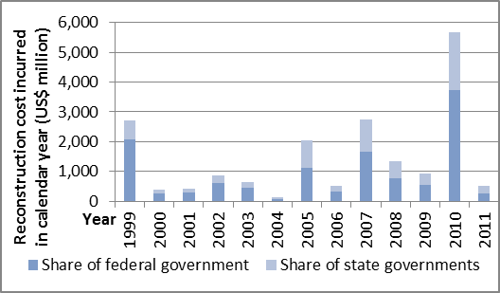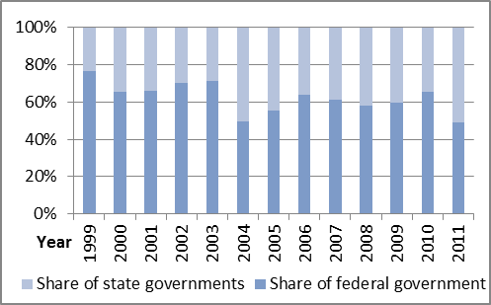
Source: Authors, from FONDEN (2011)

Disaster Risk Profile of FONDEN
The federal government supports the post-disaster reconstruction of public assets and low income housing through the FONDEN program. It meets the cost of reconstruction of federal assets in full and covers 50 percent of the cost of reconstruction of eligible state assets and low income housing. Over the period 1999 to 2011, on average FONDEN spent US$339 million per annum on the reconstruction of federal assets and US$600 million per annum on the reconstruction of state assets and low-income housing.
Figure 4.3. Post-disaster reconstruction costs paid by FONDEN for damaged federal assets and state assets (in constant 2011 US dollars)
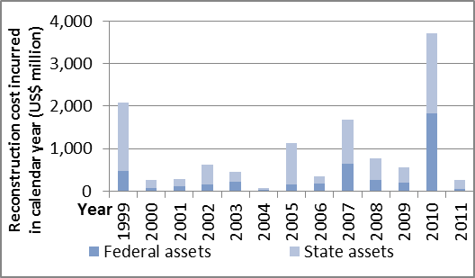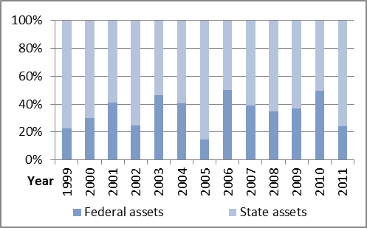
Source: Authors, from FONDEN (2011)
Much of this expenditure was concentrated on the reconstruction of roads, hydraulic infrastructure, and low-income housing. The reconstruction of federal and local roads alone accounted for over half of FONDEN’s total reconstruction spending, followed by the reconstruction of hydraulic infrastructure (27 percent) and low income housing (9 percent). Figure 4.4 shows FONDEN’s spending by types of asset for the period 2000 to 2011.
Figure 4.4. Post-disaster reconstruction costs covered by FONDEN, by type of assets, 2000-2011
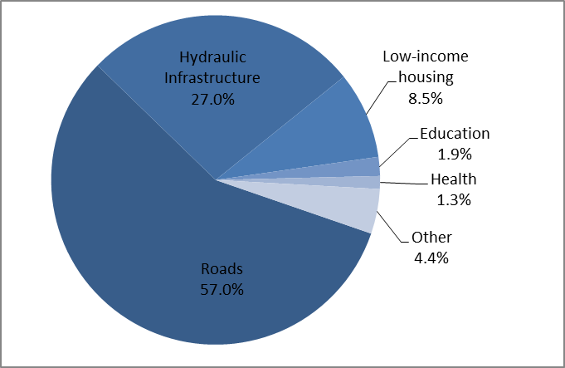
Source: Authors, from FONDEN (2011)
Excess rainfall, flooding and windstorms were responsible for the vast majority (93 percent) of reconstruction costs between 2000 and 2011. Earthquakes, droughts and landslides were each responsible for less than 3 percent of total reconstruction costs. Figure 4.5 shows FONDEN’s spending by peril for the period 2000 to 2011.
Figure 4.5. Post-disaster reconstruction costs covered by FONDEN, by type of peril, 2000-2011
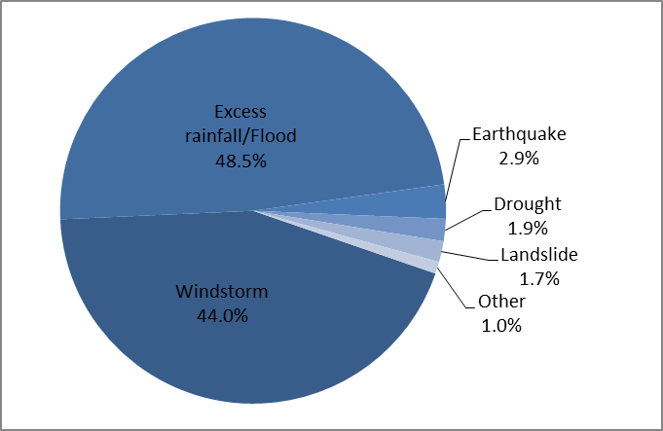
Source: Authors, from FONDEN (2011)
A majority (67 percent) of reconstruction costs met by FONDEN between 2000 and 2011 benefitted just five states, over half of which (36 percent) of total reconstruction costs) related to windstorms and flooding in 2010. Most of the reconstruction costs in respect of assets in Nuevo León (90 percent) were caused by events in 2010, as were around half (between 44 and 45 percent) of the costs of the other four states with the largest historical reconstruction costs paid by FONDEN, Veracruz, Tabasco, Chiapas and Oaxaca. Figure 4.6 shows FONDEN’s spending by state for the period 2000 to 2011.
Figure 4.6. Post-disaster reconstruction costs covered by FONDEN, by state, 2000-2011
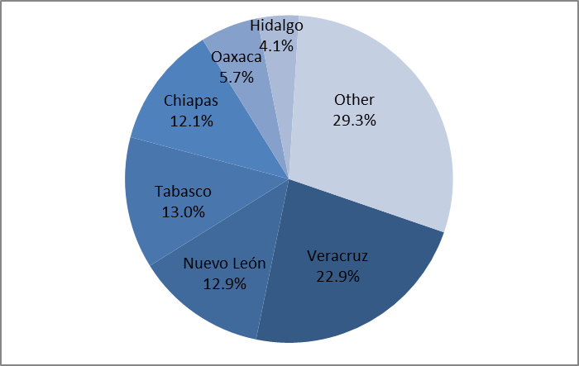
Source: Authors, from FONDEN (2011)

Disaster Risk Financing Strategy of FONDEN
FONDEN’s support for post-disaster reconstruction is financed through FONDEN’s annual federal budget appropriation and from reserves in the FONDEN Trust. Over US$500 million per annum was allocated from the federal budget to FONDEN in the early years of the program (1999-2001) but this allocation was drastically reduced in subsequent years, as indicated in Figure 4.5. Major flood losses in 2010 prompted a much higher allocation in 2011, reaching an all-time high of US$833 million.
Despite the cut in federal budget allocations from 2002 onwards, the FONDEN Trust was able to build up some reserves over time, reaching US$857 million in 2009. However, these reserves were severely depleted by the 2010 floods.
FONDEN’s approved expenditures have exceeded the combined financing available from its annual federal budget allocation and the FONDEN reserves in five of the last 13 years, with the most dramatic deficit in 2010. The federal government had to transfer over US$3.3 billion from elsewhere in its budget to meet FONDEN’s post-disaster reconstruction commitments in 2010. Article 19 of the federal budget allows for additional exceptional budget allocations of this nature for FONDEN, drawing on resources from the federal surplus (such as the oil revenue surplus) and other programs.
Figure 4.7. Resources and expenditures of FONDEN, 1999-2011 (in constant 2011 US dollars)
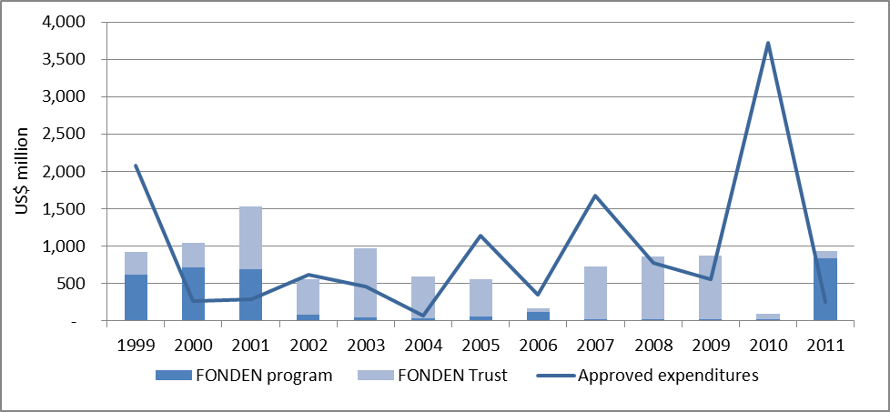
Source: Authors, from FONDEN (2011)

To help meet FONDEN’s mandated responsibilities, in around 2004 the federal government also requested FONDEN to develop its own financial strategy. This strategy has evolved over the years, based on a ‘bottom up’ approach. FONDEN began by securing funds for more frequent events and has then leveraged its financial capacity over time through a series of risk transfer instruments such as indemnity-based reinsurance and catastrophe bonds. FONDEN’s operational manual was modified in the last trimester of 2004 to allow it to transfer risk to the reinsurance and capital markets.
FONDEN’s disaster risk financing strategy as of 2011 is illustrated in Figure 4.8 below. The bottom layer of risk, up to US$1 billion, is retained by FONDEN through its annual budget appropriation and, if necessary, by an exceptional additional federal budget allocation (mainly from oil surplus revenues). The US$400 million layer in excess of this US$1 billion is covered through an indemnity-based reinsurance policy on the whole FONDEN portfolio. Should the total reconstruction costs exceed US$1.4 billion, these excess losses are financed through a further exceptional budget allocation. FONDEN has also issued a cat bond to provide immediate liquidity should a major earthquake and/or hurricane occur in pre-defined areas of the country. These risk financing instruments are further described below.
Figure 4.8. 2011 FONDEN disaster risk financing strategy
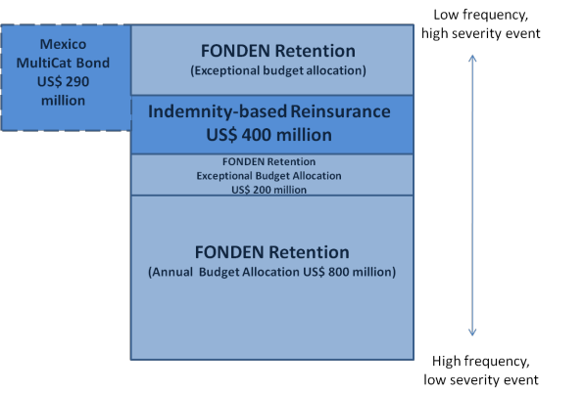
Source: Authors, from FONDEN (2011)

Annual Budget Allocation
As already noted, the federal government established a new law in 2006 that requires at least 0.4 percent of Mexico’s federal annual budget, net of the FONDEN Trust reserves, to be allocated for FOPREDEN, the Agricultural Fund for Natural Disasters, the FONDEN Revolving Fund, the FONDEN Program for Reconstruction and the FONDEN Trust. These funds are earmarked at the beginning of the fiscal year and subsequently financed by federal revenues or reserves as needed for approved activities. Annual budget allocations have ensured continued financial support for FONDEN. However, the minimum 0.4 percent requirement has become the standard actual budget allocation for FONDEN, rather than a floor.
There have also been large deviations between the amount of funding earmarked for FONDEN and the level of resources required for post-disaster activities, as shown in Figure 4.7. Demand for resources has varied between years depending on the frequency and intensity of natural hazard events in a particular year, combined with the exposure and vulnerability of affected populations and public assets. On the supply side, the FONDEN Trust is not exactly a multi-year reserve fund as the annual budget allocation of 0.4 percent is net of the reserves in the FONDEN Trust.
If the annual budget allocation proves insufficient, FONDEN can receive an exceptional budget allocation from the federal government’s reserve funds or other programs, as already noted. In recent years, some of the income surplus from Mexico’s oil revenues has been redirected to cover FONDEN financing gaps for post-disaster activities. In 2010, the exceptional allocation needed to meet all FONDEN’s commitments was around US$993 million.
In anticipation of potential funding gaps in the future, Mexico’s Ministry of Finance, the General Coordination of Civil Protection of the Ministry of Interior and other federal and state agencies are working together to further diversify FONDEN’s disaster risk financing strategy. Efforts are being made to ensure that sufficient resources are available on a sustainable basis via the creation of an adequate reserve fund for FONDEN. This initiative is intended to reduce FONDEN’s exposure to variations in its annual budgetary appropriation from the federal government, in turn due to factors such as fluctuations in oil and other commodity prices, while also minimizing the need to redirect public finances from other federal programs into FONDEN in years of catastrophic loss, such as occurred in 2010.

Risk Transfer Instruments – Indemnity-based reinsurance
In June 2011, the Mexican federal government placed an indemnity-based excess-of-loss reinsurance treaty of US$400 million in excess of US$1 billion. Reinsurance payouts are based on the losses borne by FONDEN, as reported to FONDEN. Only the replacement costs, which on average represent 75 percent of total reconstruction costs, are covered by the reinsurance treaty.

Risk Transfer Instruments – Catastrophe bond
Over the past five years, the federal government has introduced several risk transfer instruments to reduce its fiscal exposure. These instruments transfer risk to the international financial markets. They are intermediated by the Mexican public insurance company, Agroasemex.
In 2006, FONDEN issued the world’s first government catastrophe (cat) bond, CatMex, providing cover against earthquakes in three specific zones of the country. This US$160 million cat bond, combined with US$290 million parametric reinsurance coverage for the same three zones, provided protection up to US$450 million over a period of three years. According to the terms of the cat bond, a payout would be triggered if two conditions were met: (i) an official state of emergency or disaster declaration was issued by the Ministry of the Interior; and (ii) an earthquake of a specified magnitude and depth and an epicenter within pre-defined zones was recorded. Figure 4.9 summarizes these parametric details.
Figure 4.9. Features of CatMex’s Parametric Triggers
Zone C: Outer Mexico City
-106
-105
-104
-103
-102
-101
-100
-99
-98
-97
-96
-95
14
15
16
17
18
19
20
21
22
23

Source: FONDEN (2011).

After CatMex matured in October 2009, the Government of Mexico decided to further diversify its coverage by pooling multiple risks in multiple regions. In October 2009, the federal government issued a multi-peril cat bond using the World Bank’s newly established MultiCat Program. This US$290 million, four-tranche cat bond with a three-year maturity is known as MultiCat Mexico. It provides binary parametric insurance to FONDEN against earthquake risk in three regions around Mexico City and against hurricanes on the Atlantic and Pacific coasts. For the continued earthquake cover, trigger levels were reduced to include more events and the zones covered extended in order to protect a larger population. In the event of a disaster, an insurance claim will be triggered if an official declaration of a state of emergency is issued by the Ministry of the Interior and the event also meets certain other criteria. The principal will be repaid to investors if no claims are triggered over the life of the cat bond. The cost of the bond tranches are between 2.5 and 4.3 times the expected loss. Table 4.XX summarizes the main features of the MultiCat.
Table 4.XXX. MultiCat Mexico 2009 – Summary of Terms
 | Class A | Class B | Class C | Class D
Peril | Earthquake | Pacific Hurricane | Pacific Hurricane | Atlantic Hurricane
Notional (US$ million) | 140 | 50 | 50 | 50
S&P rating | B | B | B | BB-
Maturity | October 2012 | October 2012 | October 2012 | October 2012
Interest Spread  (over US Treasury Money Market Fund) | 11.50% | 10.25% | 10.25% | 10.25%
Annual Expected loss | 4.65% | 4.07% | 4.22% | 2.39%
Multiple | 2.47 | 2.52 | 2.43 | 4.29
Source: FONDEN (2011).

Figure 4.11. Features of MultiCat’s Parametric Triggers
Earthquake Triggers
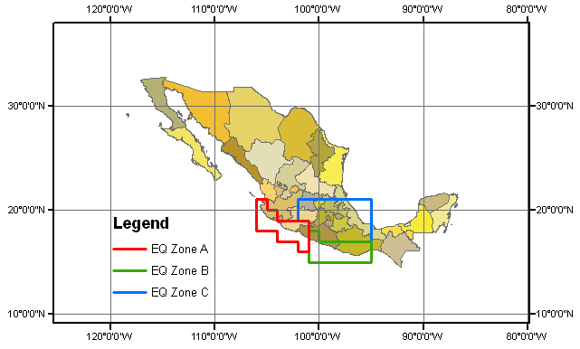
Hurricane Triggers
Trigger
North Pacific Area
C Michoacán
South Pacific Area
B Baja California
Atlantic Yucatán
Category
4
4
5
Sum Insured
50 md
50 md
50 md
Zone

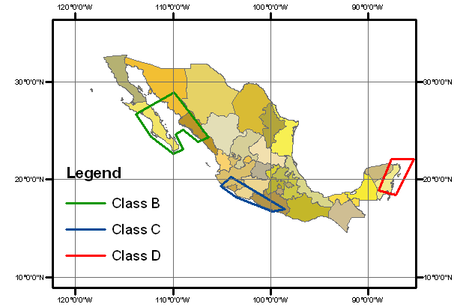
Source: FONDEN (2011).

Enhancing Disaster Risk Financing and the Insurance Strategy
Since 2007, the FONDEN Trust Technical Committee has conducted various studies to better assess natural disaster risks in Mexico. An in-depth review of FONDEN’s financial exposure to natural disasters has been undertaken through an initiative on the ‘Design of financial mechanisms to protect the assets of the FONDEN Trust against the risks of earthquake, flood and tropical cyclone’. The first phase focused on the primary types of asset affected by natural disasters, such as roads and bridges, hospitals, schools, hydraulic infrastructure, and housing for low-income populations. This phase was concluded in 2009 and involved three main stages: (i) the development of an asset inventory database of the main agencies in charge of federal infrastructure (including SCT, SEP, SSA, and SEDESOL) and the centralized agencies responsible for assessing disaster risks including the National Institute of Statistics and Geography (Instituto Nacional de Estadística y Geografía - INEGI), CENAPRED, and the Navy (Secretaría de Marina- SEMAR); (ii) hazard risk modeling for earthquakes, hurricanes and floods; and (iii) the development of a financial model to design disaster risk financing and insurance strategies for FONDEN. These components were integrated into a federal catastrophe risk model (R-FONDEN), developed in partnership with the Institute of Engineering from the National University of Mexico . GIS techniques also contributed to the development of visual illustrations in the form of risk maps, improving the identification of potential areas of loss while supporting civil protection activities. See Box 4.1 for a description of R-FONDEN.
Box 4.1. Risk Analysis with R-FONDEN
R-FONDEN is a probabilistic catastrophe risk model developed by the National University of Mexico (UNAM). It covers four major perils (earthquake, floods, tropical cyclones, and storm surge) for assets in key sectors (education, health, roads, and low-income housing) at the national, state and local level.
R-FONDEN can perform analysis on either a scenario or probabilistic basis. It takes as input a detailed exposure database, including information on buildings, roads and other public assets, and produces as outputs risk metrics such as Annual Expected Loss (AEL) and Probable Maximum Loss (PML). Its exposure database currently covers approximately 90 percent of federal government assets and 30 to 50 percent of state government assets.
. 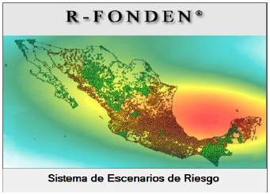 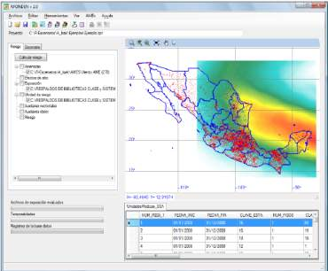

R-FONDEN has been used to improve the individual insurance policies of participating agencies. For instance, the model was used to design the property catastrophe risk insurance programs for SCT and SEP, leading to a 20 percent decrease in insurance premiums. The federal government is also investigating the possibility of purchasing insurance cover for national roads.
Likewise, the federal government is investigating financial risk transfer mechanisms for low-income housing. The housing sector remains one of the most vulnerable to natural disasters, with approximately 41 percent of housing in Mexico classified as low-income housing according to SEDESOL. Approximately 2.8 million low-income houses are located in high earthquake risk zones and 3.2 million in high hurricane risk zones. Low-income housing is particularly vulnerable to disasters due to poor construction materials. The federal government is investigating financial risk transfer schemes against floods as well as earthquakes and hurricanes for public assets and low-income housing.
The Federal Government of Mexico also supports states in improving their understanding of disaster risks and developing disaster risk financing strategies. In 2011, a new initiative was launched to increase the involvement of state governments in the design of financial risk transfer schemes (see revised Chapter 7 of FONDEN’s operational guidelines). This initiative aims to assist state governments in developing inventories of public assets and low-income housing (including attributes such as type of construction, year of construction, replacement cost, location and past damage) that are eligible for insurance and in conducting studies to identify and quantify their vulnerability to natural hazards. FONDEN provides state entities with technical and/or financial support for the development of integrated risk management systems. Financial support is available for several activities as listed in Figure 4.12.
Figure 4.12. Financial Support to Promote Integrated Risk Management Systems
Actions to Support Integrated Risk Management | Financial Support from Federal Government  (Percentage of Total Costs of the Strategy) | Timeframe for Implementation
Identification of Assets | Up to 70% | 6 months
Risk Assessment | Up to 70% | 5 months
Identification of Risk Transfer mechanisms | Up to 70% | 3 months
Source: Mexico’s Ministry of Finance (2011)

A Reconstruction Fund for Local Entities was piloted following the major floods of 2010, with a MXN 4.5 billion (US$328 million) contribution from the federal budget. This contribution is intended to guarantee zero coupon loans with a 20-year maturity issued by the Ministry of Finance through the public bank Banobras to states that have suffered disasters since January 1, 2010 and that have requested FONDEN support. Under this Fund, Banobras can issue loans up to a combined total value of MXN 22 billion (US$1.5 billion). Individual state governments can apply for loans from the Fund up to a value not exceeding their required contribution to FONDEN-supported reconstruction efforts as determined by the FONDEN Trust Technical Committee. At the end of the loan period, the states only pay the interest on their loans while the Fund pays the principal. The Reconstruction Fund for Local Entities did not receive an allocation under the 2012 federal budget, however, and once the Fund’s initial allocation is fully utilized it will probably cease operation, since it was created only as a temporary rescue fund to help the States to face the enormous disbursement needed to attend 2010 natural disasters.

Chapter 5: Towards Integrated Risk Management
This chapter describes the ongoing development of the integrated risk management framework in Mexico, including remaining challenges. Based on Mexico’s experience with FONDEN, lessons can be learned and shared with other countries that are interested in developing an integrated disaster risk management strategy, including a disaster risk financing and insurance strategy.

Mexico’s Approach to Comprehensive Risk Management
The Federal Government of Mexico has consolidated its disaster risk management strategy by linking disaster risks with national priorities and development objectives. Mexico has integrated disaster risk management into its national plans and programs for 2007-2012 to ensure a comprehensive strategy and coordinated approach at the national level.
Disaster risk financing and insurance is considered an important component of the broader disaster risk management framework, as reflected in the design of Mexico’s Natural Disaster Fund, FONDEN. FONDEN is anchored in the country’s national system of civil protection, which has a mandate to protect Mexican society against disasters. FONDEN was created to facilitate post-disaster emergency response, recovery and reconstruction at the federal and state levels. Its financial instruments have also been designed to provide incentives for the federal and state governments to manage their disaster risks.
Disaster risk prevention has become more critical over time because of the rising cost of post-disaster recovery and reconstruction. The Government of Mexico recognizes that prevention is cost-effective, hence the emphasis placed by the FONDEN Program for Reconstruction on “building back better”. Additional ex ante measures are required to reduce fiscal exposure to disasters and thereby generate substantial savings on post-disaster response that could be directed to support development and economic growth instead. To date, only limited resources have been allocated for prevention activities relative to those spent on post-disaster reconstruction. Between 2005 and 2010, US$4,731 million was disbursed by FONDEN for reconstruction purposes compared to just US$114 million by FOPREDEN for prevention (FONDEN 2011). The latter is equivalent to less than 3 percent of FONDEN’s expenditure on reconstruction. In the medium-term, the merger of FONDEN and FOPREDEN is being considered to ensure better integration of financial support for, variously, risk identification, prevention, mitigation, preparedness, emergency response, recovery and reconstruction.
The Government of Mexico supports the development of risk assessment tools to enhance planning processes and related investment decisions. The integration of risk identification and modeling activities into planning processes can significantly improve risk management, reducing future reconstruction costs. Technical agencies dedicated to risk identification and hazard analysis provide a critical service that can benefit both federal and state entities. By ensuring a strong link between its technical arm (CENAPRED) and its financial arm (FONDEN), the Government of Mexico will be better positioned to identify, understand, and take the necessary measures to address disaster risks.
In recognition of its considerable fiscal liability for the physical and economic impacts of natural disasters, the Government of Mexico has leveraged the role of the private sector and capital markets to diversify and spread its disaster risks. A variety of disaster risk financing instruments has been developed and applied to transfer risks and related exposure, involving the strategic use of insurance and cat bond options. Mexico has been able to issue these sophisticated financial instruments in private markets based on its strong institutional capacity and access to global capital markets.

Lessons Learned
Since the establishment of FONDEN in 1996, several lessons have been learned resulting in changes to FONDEN’s procedures. Continuous improvements have allowed the Government of Mexico to progressively enhance FONDEN’s role and its ability to efficiently and effectively manage its resources to support ex ante and ex post activities.
Excessive physical and social costs are incurred as a consequence of natural disasters in the absence of national and local investments in prevention. Countries seeking to minimize vulnerability to disasters can benefit by determining an appropriate balance of spending between prevention and reconstruction. In common with Mexico, many other countries are also taking cost-effective measures to reduce social and economic exposure to disasters. For instance, multi-hazard assessments can help to significantly reduce disaster risks when integrated into urban planning and taken into consideration when investing in federal and local infrastructure, influencing both the design and location of assets.
Sophisticated financial instruments can enhance a country’s disaster risk management program. However, their scope for application depends on a country’s technical capability and extent of access to capital markets. It is useful for countries to consider the strength of domestic capital markets and their level of access to international capital markets in exploring feasible financing instruments.
The innovative use of technology can improve the transparency and control of resources for both prevention and post-disaster reconstruction. In the case of Mexico’s FONDEN, the requirement for georeferenced photographic images to be provided to the Damage Assessment Committee has helped FONDEN to record and manage its resources for the reconstruction of federal and local infrastructure efficiently.

Conclusion
Based on FONDEN’s experiences to date, this study has identified several areas for further consideration and subsequent action to maximize the Government of Mexico’s ability to effectively protect its people and public infrastructure against disasters:
- Legal reforms are required to incorporate disaster risk management into national development policy. This would help to ensure that prior analysis of disaster risks is undertaken before federal budget decisions are made, helping to reduce disaster risks while also potentially avoiding or minimizing post-disaster funding shortfalls.
- Financial instruments for the prevention of natural disasters need to be further strengthened to help ensure that there is a cost-efficient balance of expenditure between post-disaster response and reconstruction and prevention and risk reduction. A proposal for a Joint Reserve Fund for the Mexican states is currently being considered by the Government of Mexico; and prevention and disaster risk reduction components are increasingly being integrated into Mexico’s public investments.
- Further analysis is required to strengthen understanding of disaster risks and to identify appropriate risk reduction measures in order to support a shift in emphasis from post-disaster support towards ex ante risk reduction.
- The continued promotion of information and training to enhance the general public’s awareness of the opportunities for and benefits of disaster risk reduction and prevention are essential in fostering a culture of self-protection.

- An integrated disaster risk financing strategy for FONDEN and the Mexican states should be further developed, building on the various risk retention and risk transfer instruments currently available, to increase the fiscal resilience of the federal and state governments against natural disasters.

References

CENAPRED (2000)…
CENAPRED (2010)…
CENAPRED (2011)…
Cummins, J.D. and O. Mahul (2009). “Catastrophe Risk Financing in Developing Countries: Principles for Public Intervention”. The World Bank, Washington, DC.
FONDEN (2011)…
Mexico’s Ministry of Finance (2011)
Mexican Civil Protection (2010)…
Secretaría de Gobernación (2009). FONDEN Operating Rules, Published in the Official Diary of the Mexican Federation, 27 May 2009.

Secretaría de Gobernación (2008). National Program of Civil Protection 2008-2012. Published in the Official Diary of the Mexican Federation, 19 September, 2008.

Secretaría de Gobernación (2011). New General Rules and Specific Operating Guidelines for FONDEN, Published by Mexico’s National Civil Protection. 31 January 2011. Information can be accessed online at www.proteccioncivil.gob.mx.
SHCP (2011)…
RMS Database Report, “Design of financial mechanisms to protect the FONDEN Trust patrimony against earthquakes, floods and tropical cyclones” – Data base creation and processing, by UNAM’s Instituto de Ingeniería, (2008)

UNAM (2010). "Design of financial mechanisms to protect the FONDEN trust patrimony against earthquakes, floods and tropical cyclones”. Prepared by UNAM Instituto de Ingenieria.

World Bank (2005). “Natural Disaster Hotspots: A Global Risk Analysis”. Disaster Risk Management Series No. 5, Hazard Management Unit, The World Bank
World Bank (2009). “Global Assessment Report on Disaster Risk Reduction”, United Nations International Strategy for Disaster Reduction, ISDN: 9789211320282.

Additional Resource Material

Secretaría de Gobernación, Fondo de Desastres Naturales, http://www.proteccioncivil.gob.mx/Portal/
PtMain.php?nIdHeader=2&nIdPanel=391&nIdFooter=22.

Secretaría de Hacienda y Crédito Público, Cuenta de la Hacienda Pública Federal, varios años 2000-2009, México, D.F.

Secretaría de Hacienda y Crédito Público, Presupuesto de Egresos de la Federación, varios años, 2000-2009,
México, D.F.

http://earthquake.usgs.gov/earthquakes/recenteqsww/Quakes/ci14607652.php
http://redalyc.uaemex.mx/pdf/417/41702304.pdf
http://specialpapers.gsapubs.org/content/402/253.abstract
http://www.cefp.gob.mx/publicaciones/nota/2010/junio/notacefp0192010.pdf
http://www.cefp.gob.mx/notas/2007/notacefp0402007.pdf
http://www.cenapred.gob.mx/es/QuienesSomos/
http://www.diputados.gob.mx/LeyesBiblio/pdf/141.pdf
http://www.eclac.cl/publicaciones/xml/5/33645/PrincINGFinal.pdf
http://www.eclac.org/publicaciones/xml/4/31414/Serie_92.pdf
http://www.eird.org/wikien/index.php/Mexico
http://dof.gob.mx/busqueda_detalle.php
http://www.proteccioncivil.gob.mx/en/ProteccionCivil/Apoyos_parciales_inmediatos_APIN
http://www.proteccioncivil.gob.mx/en/ProteccionCivil/Normatividad
http://www.proteccioncivil.gob.mx/en/ProteccionCivil/Preguntas_Frecuentes#q10
http://www.proteccioncivil.gob.mx/en/ProteccionCivil/Reconstruccion_FONDEN
http://www.proteccioncivil.gob.mx/upLoad/Publicaciones/Ley_General.pdf
http://www.shcp.gob.mx/EGRESOS/PEF/pef/pef_00/documentos/expo_motivos/capitulo8.pdf
http://www.un.org/en/ga/president/65/initiatives/isdr/rubem.pdf
http://216.122.62.22/attach/258/EDOCS/SRed/2010/11/T023600004520-0-FONDEN-SEGOB_Instumentos_financieros_de_prevencion_y_atencion_de_desastres.pdf

Glossary
Adverse Selection | Adverse selection occurs when potential insurance purchasers know more about their risks than the insurer does, leading to participation by high risk individuals and nonparticipation by low-risk individuals. Insurers react by either charging higher premiums or not insuring at all, as in the case of floods.
Average Expected Loss | Expected loss per year when averaged over a very long period (for example, 1,000 years). Computationally, AEL is the summation of products of event losses and event occurrence probabilities for all stochastic events in a loss model.
Basis Risk | The risk with index insurance that the index measurements will not match individual losses. Some households that experience loss will not be covered, for example, and some households that experience no loss will receive indemnity payments. As the geographical area covered by the index increases, basis risk will increase as well.
Catastrophe | A severe, usually sudden, disaster that results in heavy losses.
Catastrophe (Cat) Bond | A high-yielding, insurance-linked security providing for payment of interest and/or principal to be suspended or cancelled in the event of a specified catastrophe, such as an earthquake of a certain magnitude or above within a predefined geographical area.
Catastrophe Risk Model | A computerized model generating a set of simulated events to calculate losses arising from a catastrophe.
Claim | An insurer’s application for indemnity payment after a covered loss has occurred.
Direct Loss | Recovery cost of the damaged assets.
Diversification | Development of a portfolio containing a variety of assets in terms of geographical or sectoral spread, or credit quality. In general, risk is reduced as portfolio diversification increases.
Ex ante risk management | Action taken prior to a potential risk event. Making preparations before a disaster helps avoid inefficient, quick-response coping decisions. If ex ante strategies are not in place, resort will be to short-term coping strategies that have no significant benefit in the long run.
Ex post risk management | Risk-management strategies that are developed in reaction to an event, without prior planning. Although ex post strategies have a role to play in a risk-management program, risk-management mechanisms can be more effective when introduced ex ante.
Exposure | The amount (sum insured) exposed to the insured peril(s) at any one time.
Georeference | To establish something’s location in terms of map projections or a coordinate system (e.g., the position of an aerial photograph within a map or the geographical coordinates of a physical asset).
Hazard | A physical or moral feature that increases the potential for a loss arising from an insured peril or that may influence the degree of damage.
Indemnity | The amount payable by the insurer to the insured, in the form of cash, repair, replacement, or reinstatement, in the event of an insured loss. This amount is measured by the extent of the insured’s pecuniary loss. It is set at a figure equal to but not more than the actual value of the objects insured just before the loss, subject to the adequacy of the sum insured.
Indirect Losses | Economic consequences of the damaged assets (e.g., foregone revenue).
Insurance | A financial mechanism that aims to reduce the uncertainty of loss by pooling a large number of uncertainties so that the burden of loss is distributed. Generally, each policyholder pays a contribution to a fund, in the form of a premium, commensurate with the risk he introduces. The insurer uses these funds to pay the losses (indemnities) suffered by any of the insured.
Insurance Policy | A formal document (including all clauses, riders, and endorsements) that expresses the terms, exceptions, and conditions of the contract of insurance between the insurer and the insured. It is not the contract itself but evidence of the contract.
Layer | A range of potential loss that is covered by insurance. For example, an insurance contract may pay indemnities only for losses within a specified range of magnitude.
Moral Hazard | In insurance, moral hazard refers to the problems generated when the insured’s behavior can influence the extent of damage that qualifies for insurance payouts. Examples of moral hazard are carelessness, fraudulent claims, and irresponsibility.
Parametric Insurance | A form of insurance that makes indemnity payments based not on an assessment of the policyholder’s individual loss, but rather on measures of a parametric index that is assumed to proxy actual losses. It is also referred to as index or index-based insurance.
Premium | The monetary sum payable by the insured to the insurers for the period (or term) of insurance granted by the policy.  Premium = premium rate x amount of insurance  Also, the cost of an option contract paid by the buyer to the seller.
Premium Rate | The price per unit of insurance, normally expressed as a percentage of the sum insured.
Probable Maximum Loss (PML) | The largest loss believed to be possible for a certain type of event in a defined return period, such as 1 in 100 years or 1 in 250 years.
Reinsurance | Insurance purchased by an insurer. When the total exposure of a risk or group of risks presents the potential for losses beyond the limit that is prudent for an insurance company to carry, the insurance company may purchase reinsurance. Reinsurance has many advantages, including 1) leveling the results of the insurance company over a period of time; 2) limiting the exposure of individual risks and restricting losses paid out by the insurance company; 3)possibly increasing an insurance company’s solvency margin (percent of capital and reserves to net premium income), hence the company’s financial strength; and 4) enabling the reinsurer to participate in the profits of the insurance company, but also to contribute to the losses, the net result being a more stable loss ratio over the period of insurance.
Risk Assessment | The qualitative and quantitative evaluation of risk. The process includes describing potential adverse effects, evaluating the magnitude of each risk, estimating potential exposure to the risk, estimating the range of likely effects given the likely exposures, and describing uncertainties.
Risk Financing | The process of managing risk and the consequences of residual risk through products such as insurance contracts, cat bonds, reinsurance, or options.
Risk Layering | The process of separating risk into tiers that allow for more efficient financing and management of risks.
Risk Management | Care to maintain income and avoid or reduce loss or damage to a property resulting from undesirable events. Risk management involves identifying, analyzing, and quantifying risks and taking appropriate measures to prevent or minimize losses. Risk management may involve physical mechanisms, such as spraying a crop against aphids, using hail netting, or planting windbreaks. It can also involve financial mechanisms such as hedging, insurance, and self-insurance (carrying sufficient financial reserves so that a loss can be sustained without endangering the immediate viability of the enterprise in the event of a loss).
Risk Mitigation | Actions taken to reduce the probability or impact of a risk event, or to reduce exposure to risk events.
Risk Pooling | The aggregation of individual risks to manage the consequences of independent risks. Risk pooling is based on the law of large numbers. In insurance terms, the law of large numbers demonstrates that pooling large numbers of roughly homogenous, independent exposure units can yield a mean average consistent with actual outcomes. Thus, pooling risks allows an accurate prediction of future losses and helps determine premium rates.
Risk Retention | The process whereby a party retains the financial responsibility for loss in the event of a shock.
Risk Transfer | The process of shifting the burden of financial loss or responsibility for risk financing to another party, through insurance, reinsurance, legislation, or other means.
Total Economic Losses | Sum of direct and indirect losses.

Annexes

ANNEX 1 Description of Phenomena Identified in Mexico’s General Law of Civil Protection
ANNEX 2 Selected Earthquakes in Mexico of General Historic Interest
ANNEX 3 Mexican States and Federal District Populations
ANNEX 4 Members of FONDEN Trust Technical Committees – Federal and State Trusts
ANNEX 5 Disaster Declarations by Mexican States in 2009
ANNEX 6 FONDEN’s Previous Fund Allocation Process until 2010
ANNEX 7 Overview of FONDEN’s New Procedures from 2011
ANNEX 8 Practical Examples of Disaster Events and Access to FONDEN Resources in 2010
ANNEX 9 Examples of Authorized Resources for Disaster Declarations in 2011
ANNEX 10 Examples of Funds Approved for Immediate Partial Support in 2011

ANNEX 1: Description of Phenomena Identified in Mexico’s General Law of Civil Protection

- Geological Phenomenon: A disaster caused by the actions and violent movements of the earth’s crust. This category includes seismic movements or earthquakes, volcanic eruptions, tsunamis or tidal waves, and soil instability, also known as earth movements. The latter may take a number of different forms: slow movement or creeping, sliding, flow or current, avalanche or landslide, collapse or sinking.
- Hydrometeorological Phenomenon: A disaster caused by the violent action of atmospheric forces, such as hurricanes; floods from rains, rivers, coasts, and lakes; snow, hail, dust, and electrical storms; freezes; droughts and heat and cold waves.
- Chemical-Technological Phenomenon: A disaster caused by the violent action of different substances resulting from their molecular or nuclear interaction. Includes destructive phenomena, such as fires of any kind, explosions, toxic leaks, and radiation.
- Sanitary-Ecological Phenomenon: A disaster caused by the pathogenic action of biological agents that attack a human population, animals, and/or crops, causing their death or affecting their health. Epidemics or plagues constitute a health disaster in the strict sense of the term. This category includes air, water, soil, and food contamination.
- Socio-Organizational Phenomenon: A disaster caused as a result of human error or by premeditated actions, which takes place in large crowds or mass population movements.

Source: Official Statement by Lic. Laura Gurza Jaidar, General Coordinator, National System of Civil Protection (2009).

ANNEX 2: Selected Earthquakes in Mexico of General Historic Interest

DATE  (MONTH/DAY/YEAR) | LOCATION | MAGNITUDE | FATALITIES
05/03/1887 | Northern Sonora | 7.4 | 51
04/15/1907 | Guerrero | 7.7 | --
06/07/1911 | Off Guerrero | 7.7 | 45
01/15/1931 | Oaxaca | 7.8 | 114
06/03/1932 | Jalisco | 8.1 | 45
06/18/1932 | Colima | 7.8 | --
07/28/1957 | Guerrero | 7.9 | 68
08/26/1959 | Vera Cruz | 6.8 | 20
05/11/1962 | Guerrero | 7.0 | 4
05/19/1962 | Guerrero | 7.1 | 3
07/06/1964 | Guerrero | 6.9 | 30
08/23/1965 | Oaxaca | 7.3 | 6
08/02/1968 | Oaxaca | 7.1 | 18
10/15/1979 | Imperial Valley | 6.4 | --
09/19/1985 | Michoacán | 8.0 | 9,500
06/15/1999 | Central Mexico | 7.0 | --
09/30/1999 | Oaxaca | 7.5 | --
02/22/2002 | Near Mexicali | 5.7 | --
12/10/2002 | Mexicali, Baja California | 4.8 | --
01/22/2003 | Offshore Colima | 7.6 | 29
09/11/2003 | Near Mexicali, Baja California | 3.7 | --
06/15/2004 | Offshore Baja California | 5.1 | ---
01/04/2006 | Gulf of California | 6.6 | --
08/11/2006 | Michoacán | 5.9 | --
02/12/2008 | Oaxaca | 6.5 | --
08/03/2009 | Gulf of California | 6.9 | --
12/30/2009 | Baja California | 5.9 | --
04/04/2010 | Baja California | 7.2 | 2

Source: http://earthquake.usgs.gov/earthquakes/world/historical_country.php#mexico

ANNEX 3: Mexican State and Federal District Populations

RANK | MEXICAN STATE | POPULATION (2000) | POPULATION (2005) | POPULATION (2010)
1 | State of Mexico | 13,096,686 | 14,007,495 | 15,175,862
2 | Mexico City | 8,605,239 | 8,720,916 | 8,851,080
3 | Veracruz | 6,908,975 | 7,110,214 | 7,643,194
4 | Jalisco | 6,322,002 | 6,752,113 | 7,350,682
5 | Puebla | 5,076,686 | 5,383,133 | 5,779,829
6 | Guanajuato | 4,663,032 | 4,893,812 | 5,486,372
7 | Chiapas | 3,920,892 | 4,293,459 | 4,796,580
8 | Nuevo León | 3,834,141 | 4,199,292 | 4,653,458
9 | Michoacán | 3,985,667 | 3,966,073 | 4,351,037
10 | Oaxaca | 3,438,765 | 3,506,821 | 3,801,962
11 | Chihuahua | 3,052,907 | 3,241,444 | 3,406,465
12 | Guerrero | 3,079,649 | 3,115,202 | 3,388,768
13 | Tamaulipas | 2,753,222 | 3,024,238 | 3,268,554
14 | Baja California | 2,487,367 | 2,844,469 | 3,155,070
15 | Sinaloa | 2,536,844 | 2,608,442 | 2,767,761
16 | Coahuila | 2,298,070 | 2,495,200 | 2,748,391
17 | Hidalgo | 2,235,591 | 2,345,514 | 2,665,018
18 | Sonora | 2,216,969 | 2,394,861 | 2,662,480
19 | San Luis Potosí | 2,299,360 | 2,410,414 | 2,585,518
20 | Tabasco | 1,891,829 | 1,989,969 | 2,238,603
21 | Yucatan | 1,658,210 | 1,818,948 | 1,955,577
22 | Queretaro | 1,404,306 | 1,598,139 | 1,827,937
23 | Morelos | 1,555,296 | 1,612,899 | 1,777,227
24 | Durango | 1,448,661 | 1,509,117 | 1,632,934
25 | Zacatecas | 1,353,610 | 1,367,692 | 1,490,668
26 | Quintana Roo | 874,963 | 1,135,309 | 1,325,578
27 | Aguascalientes | 944,285 | 1,065,416 | 1,184,996
28 | Tlaxcala | 962,646 | 1,068,207 | 1,169,936
29 | Nayarit | 920,185 | 949,684 | 1,084,979
30 | Campeche | 690,689 | 754,730 | 822,441
31 | Colima | 542,627 | 567,996 | 650,555
32 | Baja California (South) | 424,041 | 512,170 | 637,026

ANNEX 4: Members of the FONDEN Trust Technical Committees

FONDEN Trust Technical Committee
(Federal Level)

Federal Government Representatives and Authority

Two Representatives of the Ministry of Finance | Voting Power
Representative of the Interior Ministry (SEGOB) | Voting Power
Representative of the Ministry of Civil Service | No Voting Authority
Representative of the FONDEN Trust (permanent invitation with mandatory attendance required at all Technical Committee meetings) | No Voting Authority

All representatives designate an alternative to ensure representation.

FONDEN Trust Technical Committee (State Level)

Government Representatives and Authority

Two Representatives of the State Government | Voting Power
Representative of Each Affected Municipality | Voting Power
Representative of the FONDEN Trust (permanent invitation with mandatory attendance required at all Technical Committee meetings) | No Voting Authority
Permanent Invitees from Federal Government:
- One Representative from the Ministry of Finance (SHCP)
- One Representative from the Ministry of the Interior (SEGOB)
- One Representative from each of the participating federal agencies

ANNEX 5: Disaster Declarations by Mexican States in 2009

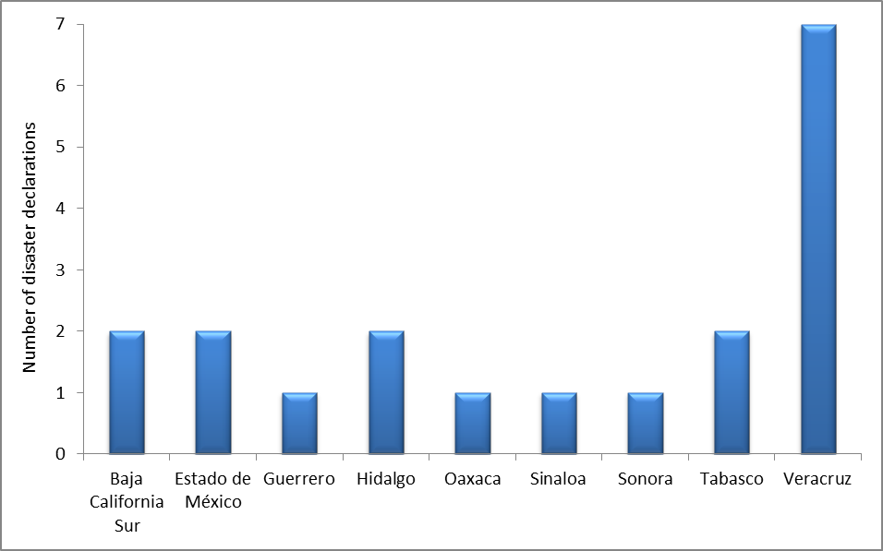

ANNEX 6: FONDEN’s Previous Fund Allocation Process until 2010

Mexico’s Federal Budget
$$
FONDEN Program $$ FONDEN Trust
for Reconstruction $$
(Previous process) FONDEN Trusts in 32 States
$$ Companies as service providers to complete works required
$$ Municipalities (only available for municipalities identified in evaluation)

Payment to Service Providers for Works

ANNEX 7: Overview of FONDEN’s New Procedures from 2011

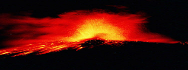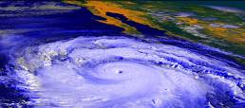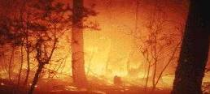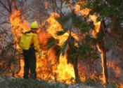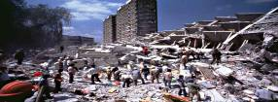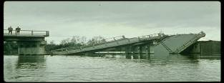
Zone A: Northwest Cocos
Zone B: Central Cocos
Mexico
City
Trigger
North Pacific Area
C Michoacán
South Pacific Area
B Baja California
Atlantic Yucatán
Category
4
4
5
Sum Insured
50 md
50 md
50 md


Issues an opinion
regarding the
occurrence of the
natural phenomena

Beginning

III. Others

Natural
Phenomena

End

II. Hydrometeorological

I. Geological

Ask for the confirmation
of the occurrence of
the natural phenomena

Zone
Beginning
I. Geological
III. Others
II. Hydrometeorological
Issues an opinion
regarding the
occurrence of the
natural phenomena
Natural

Disaster
Ask for the confirmation
of the occurrence of
the natural phenomena
Technical entity
Opinion?
Negative
Positive
End
Notifies the State
that its request
is positive
Local State
Natural
Phenomena

Opinion?

Natural Disaster

ANNEX 7 (Continued): Overview of FONDEN’s New Procedures from 2011

Request the issue
of the natural
disaster declaration
Installation of the Damage Assessment Committee
Each sector evaluates
and determines the
amounts required for
the reconstruction
Delivery of the assessment results
Request for the
rapid response
resources to realize
urgent actions
Present to the
Committee
their preliminary
lists of works and
actions to be done
Ask for resources
to conduct the
assessment
Issue and publish
the natural disaster
declaration
in the official
national newspaper
Local State
Local State
Federal Agencies
Ask for advances
to start the
reconstruction
Local State
SHCP
SEGOB
Authorizes the
rapid response
resources to
realize the
urgent actions

ANNEX 8: Illustrative Examples of Disaster Events and Access to FONDEN Resources in 2010

Earthquake occurrence in Baja California with a magnitude of 7.2 located at 32.259°N, 115.287°W with a depth of 10 kilometers.
The Government of the State of Baja California asked the National Center for Disaster Prevention (CENAPRED) for a technical opinion regarding the occurrence of an earthquake on April 4 in the state.
CENAPRED issued its opinion, confirming the occurrence of a strong earthquake on April 4, 2010, affecting the municipalities of Mexicali and Tecate.
The Damage Assessment Committee was installed. The State Government requested resources for immediate partial support (APIN) to execute priority works and emergency actions arising as a consequence of the event.
The State Government applied for a declaration of natural disaster.
Due to technical challenges in assessing the damage, an extension was requested to deliver the assessment results within an additional 10 days.
APIN resources were approved to support federal and state emergency actions and priority works in the road, hydraulic and educational sectors.
The Natural Disaster Declaration was published in the Official Journal of the Mexican Federation.
APIN resources were approved for federal support of the education sector.
The results of the damage assessment were verified at a meeting of the Damage Assessment Committee and preliminary diagnoses of required infrastructure repair and reconstruction works and action presented by the affected sectors. At the same meeting, the Federal Government requested bank advances for the necessary resources to initiate urgent reconstruction activities.
A series of fund advances were authorized to carry out urgent reconstruction activities in support of a variety of sectors, including housing, urban infrastructure, roads, hydraulic infrastructure, education, culture, sport and health.
Following receipt of the final diagnoses and respective resource requests for FONDEN support, the requests were submitted for consideration by the Technical Committee of the Federal Trust Fund. This Committee held its 110th Special Session and approved the requested resources by an agreement recorded as SE.116.01. All requested resources were authorized.
At the 13th Special Meeting of the Technical Committee of the Baja California State Trust Fund, implementation schedules for FONDEN-supported reconstruction works and actions were approved. The Committee also approved the schedule of contributions from the State Government of Baja California, covering contributions over the period May 2010 to July 2011.
At the 118th Special Session of the Technical Committee of the Federal Trust Fund, a second tranche of funding was authorized for federal support for hydraulic infrastructure reconstruction. This step concluded FONDEN resource authorizations for this particular disaster occurrence.

The Government of the State of Nuevo Leon asked the National Water Commission (CONAGUA) for its technical opinion on the occurrence of severe rainfall, flooding and strong winds generated by Hurricane "Alex" over the period of June 20 to July 2, 2010 in Nuevo Leon.
The National Water Commission issued its opinion and confirmed the occurrence on July 1, 2010 in the municipalities of Anahuac, Apodaca, Cadereyta Jimenez, Cerralvo, China, Cienega de Flores, Ph.D. Coss, General Escobedo, General Treviño, Guadalupe, Hualahuises, Linares, Los Aldamas, The Ramones, Melchor Ocampo, Montemorelos, Monterrey, San Nicolas de los Garza, San Pedro Garza García, Santa Catarina, and Santiago.
The Damage Assessment Committee was installed and the Government of the State of Nuevo Leon requested resources for immediate partial support (APIN) to execute urgent works and priority actions arising as a consequence of the disaster. The State Government applied for the issue of a declaration of natural disaster and also requested an extension of up to a further 10 days to complete the damage assessment due to technical limitations.
Immediate partial support resources (APIN) were authorized for the road, hydraulic, urban, health and housing sectors.
The Declaration of Natural Disaster was published in the Official Journal of the Mexican Federation.
The State Government made its second request for additional immediate partial support (APIN).
The second APIN application was approved for additional support to the road, urban and educational sectors.
The State Government issued a third request for immediate partial support resources (APIN). This request was authorized for the affected sectors, including the road, hydraulic, education, urban and housing sectors.
The results of the damage assessment were verified at a meeting of the Damage Assessment Committee and preliminary diagnoses of required infrastructure repair and reconstruction works and action presented by the affected sectors. At the same meeting, the Federal Government also requested bank advances for the necessary resources to initiate urgent reconstruction activities.
Resources were authorized as advances to carry out urgent reconstruction activities in the housing sector.
Following receipt of the final diagnoses and the respective resource requests for FONDEN support, the requests were submitted for consideration by the Technical Committee of the Federal Trust Fund. This Committee held its 121st Special Session and approved the requests by an agreement recorded as SE.121.01. Resources were authorized for the repair of damage in the hydraulic, health, educational and environmental sectors.
At the 18th Special Session of the Technical Committee of Nuevo León’s State Trust Fund, implementation schedules for FONDEN-supported reconstruction works and actions were approved. The Committee also approved the schedule of contributions from the State Government of Nuevo Leon, covering contributions over the period October 2010 to December 2011.
At the 122nd Special Session of the Technical Committee of the Federal Trust Fund, additional funds were authorized for the repair of damage in two remaining sectors: federal highways and sport facilities. Full authorization was provided for these two sectors.
The 123rd Special Session of the Technical Committee of the Federal Trust Fund authorized a third block of resources to support the reconstruction of state infrastructure in some sectors that were slow completing their requests, including roads, urban, housing and hydrologic infrastructure. This concluded the authorization of FONDEN resources.
Based on the earlier approval of State resources, the 22nd Second Special Session of the Technical Committee of Nuevo León State Trust Fund approved the implementation schedules of works and reconstruction measures for the affected sectors, including roads, urban and housing infrastructure.

ANNEX 9: Examples of Authorized Resources for Disaster Declarations in 2011

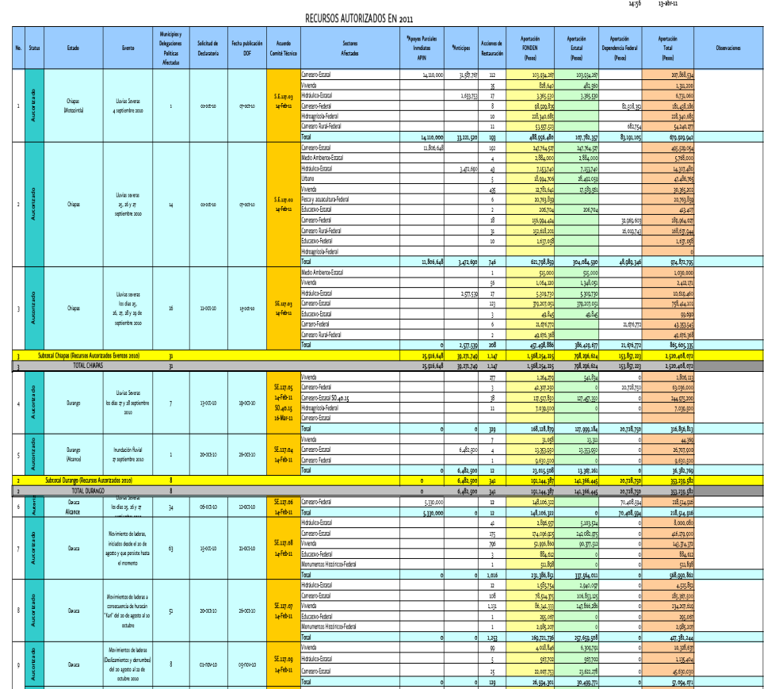
Source: http://www.proteccioncivil.gob.mx/work/models/ProteccionCivil/Resource/36/4/images/RECURSOS_AUTORIZADOS_2011_a.pdf

ANNEX 10: Examples of Funds Approved for Immediate Partial Support in 2011
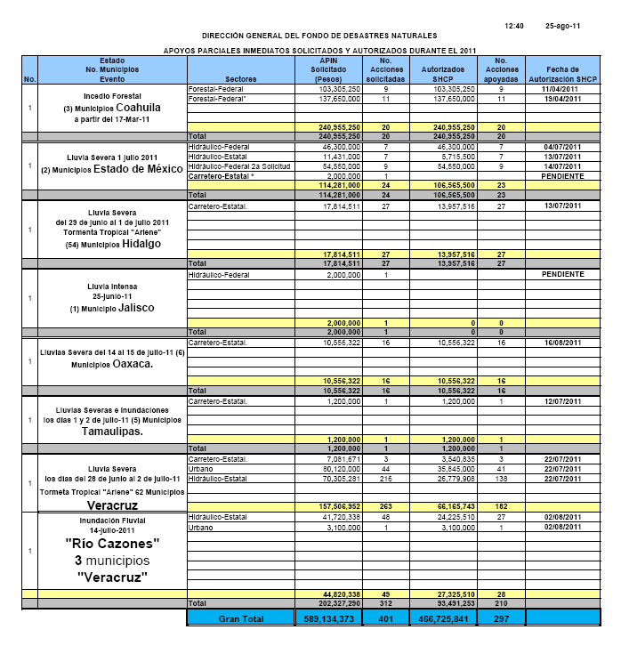
Source: http://www.proteccioncivil.gob.mx/work/models/ProteccionCivil/Resource/34/2/images/AUTORIZADOS%20APIN%202011%2025%20AGOSTO%202011%20OK.pdf

Source: http://rmcg.unam.mx/9-1/(6)Nelson.pdf
Source: http://specialpapers.gsapubs.org/content/402/253.abstract
Source: Physical Modeling Report by RMS
Source: http://www.eird.org/wikien/index.php/Mexico
Note: These images are presented for illustrative purposes only and do not provide an exhaustive representation of the type and scope of public assets in Mexico.
Conversion rate: USD 1=MXN 13.7 (as of October 5, 2011)
The Vice Ministry of Civil Protection, Prevention and Social Recovery used to sit above the General Directorate of Civil Protection. In 2001 the Organic Law for Public Administration was reformed and the Ministry of Public Security created. The Vice Ministry of Civil Protection, Prevention and Social Recovery was disbanded and the General Coordination of Civil Protection created.
Damage to the agricultural sector and livestock is covered by a special fund, the Natural Disasters Attention Component in the Agricultural, Livestock and Fishery Sector of the Prevention and Risk Management Program from the Ministry of Agriculture, Livestock, and Rural Development. However, damage to infrastructure for fisheries and aquaculture, as well as restoration of lagoon systems, coastal estuaries, bays and inland waters within the public domain can be covered by FONDEN in accordance with its General Rules and Specific Operating Guidelines.
Stipulated in Article 4, Section V and 21 of FONDEN’s General Rules and paragraphs 35 to 37 of the FONDEN Guidelines.
The General Law of Civil Protection allows for a longer 12 calendar days from the date of application for the declaration of a natural disaster to the issue of a disaster declaration. FONDEN’s rules and guidelines are stricter but, nevertheless, in accordance with the law.
Source: http://www.proteccioncivil.gob.mx/es/ProteccionCivil/Georreferencia
Source: http://www.cenapred.unam.mx/es/
All earthquake dates listed are UTC, not local time.
Source: http://en.wikipedia.org/wiki/List_of_Mexican_states_by_population
Note: Federal representatives participate within their respective scope of mandate and responsibilities.
Source: FONDEN (2011).
Source: http://earthquake.usgs.gov/earthquakes/recenteqsww/Quakes/ci14607652.php
The federal hydraulic sector was the most severely affected sector and was unable to complete its entire damage assessment within the required timeframe. It was therefore agreed that its request for FONDEN support would be split into two tranches to allow some reconstruction work to begin while the second part of the damage assessment was completed.
Source: FONDEN (2011).
As of May 6, 2011

